**EAST WEST UNIVERSITY**

Department of Electrical and Electronic Engineering

EEE 307 : Telecommunication Engineering

**Experiment No 05: Generation of PAM and TDM signal and reconstruction of the message signal**

**Submitted by**

[Puja Pandit]

[2012-1-85-014]

Group no: 03

Group Members name: Puja Pandit ID: 2012-1-85-014

Atika Mansur Nirzona ID: 2012-1-80-045

Md. Mozahedul Islam ID: 2012-1-80-003

Nishat Khan Rimi ID: 2012-1-80-027

Shohanur Rahman ID: 2012-1-80-012

Sheikh Md. Razoan ID: 2010-2-80-035

Course Instructor: MBS

Date of performance: 02.11.2014

Date of submission: 25.11.2014

**Objective:** The objective of this experiment is to learn about the construction of TDM (Time Division Multiplexing) signals and to recover the message signals from the reconstructed TDM signals. We have also figure out samples of audio signal and proved the Nyquist sampling theorem.

**Circuit Diagram:**



Fig 01: PAM signal Generation

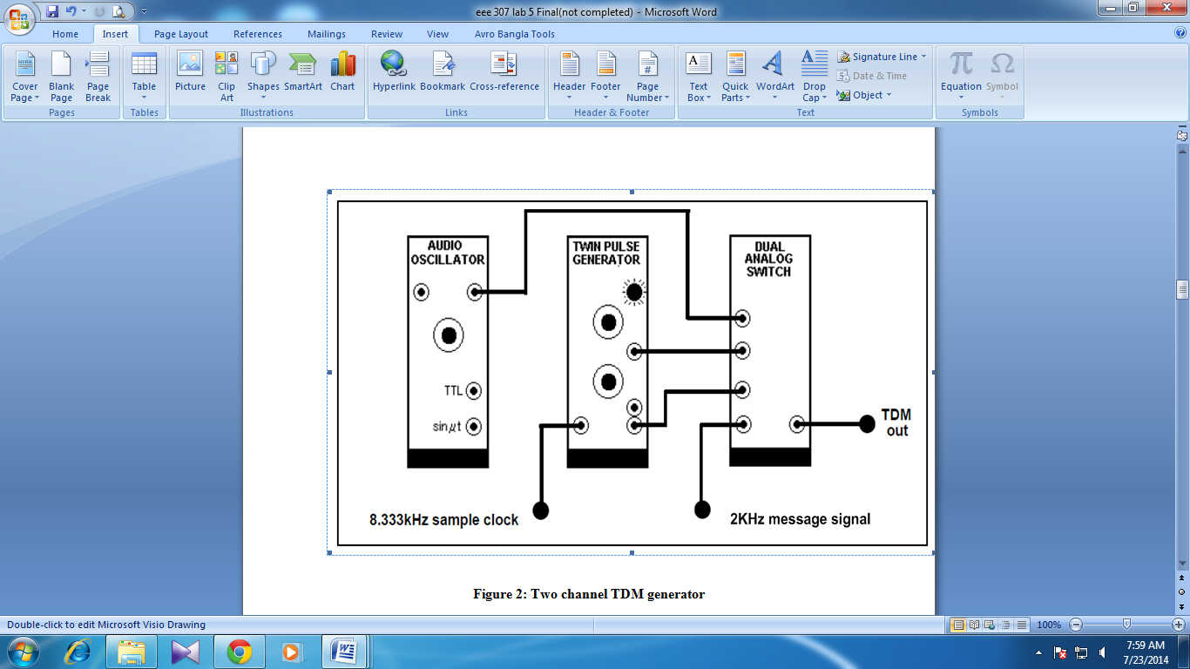

Fig 02: Two channel TDM generator

**Experimental Results:**

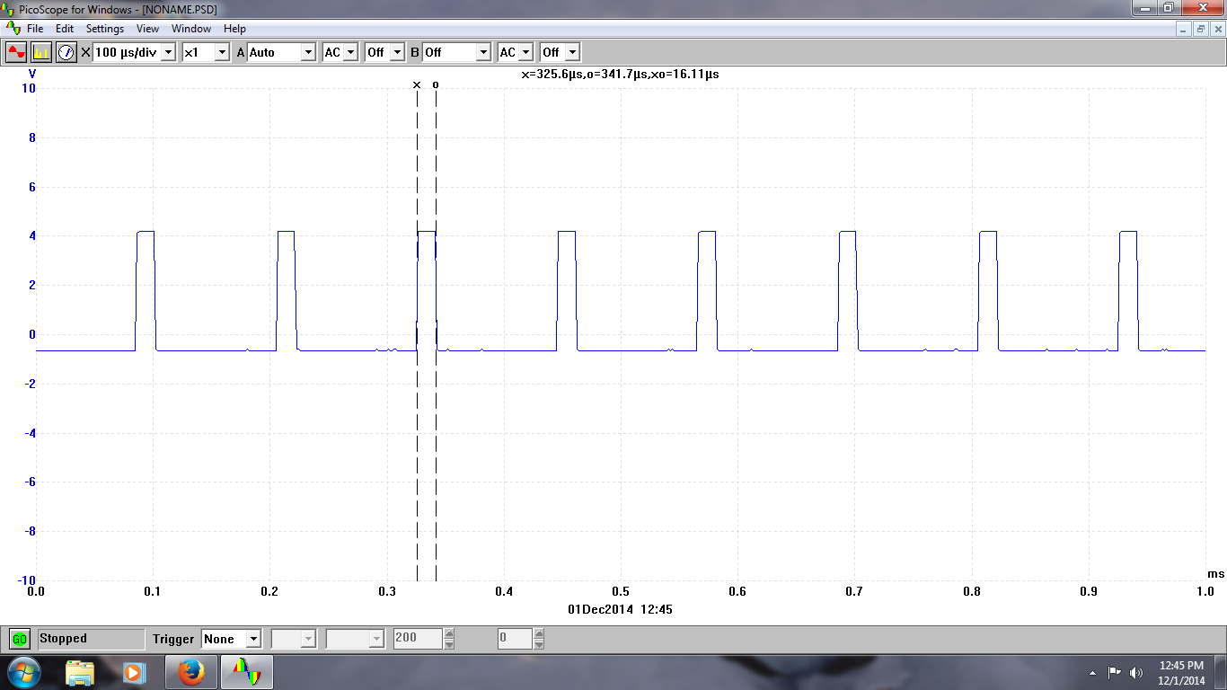

Fig 01: Channel output1

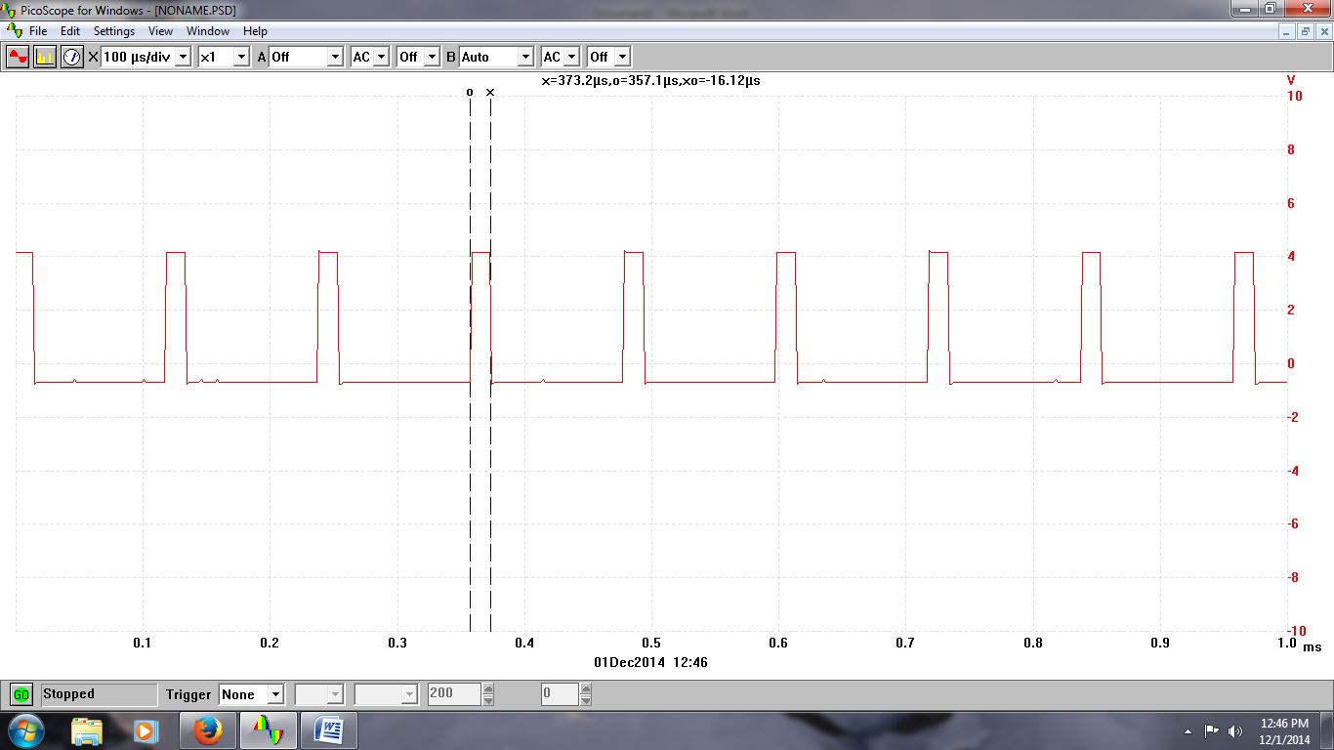

Fig 02: Channel 2 output

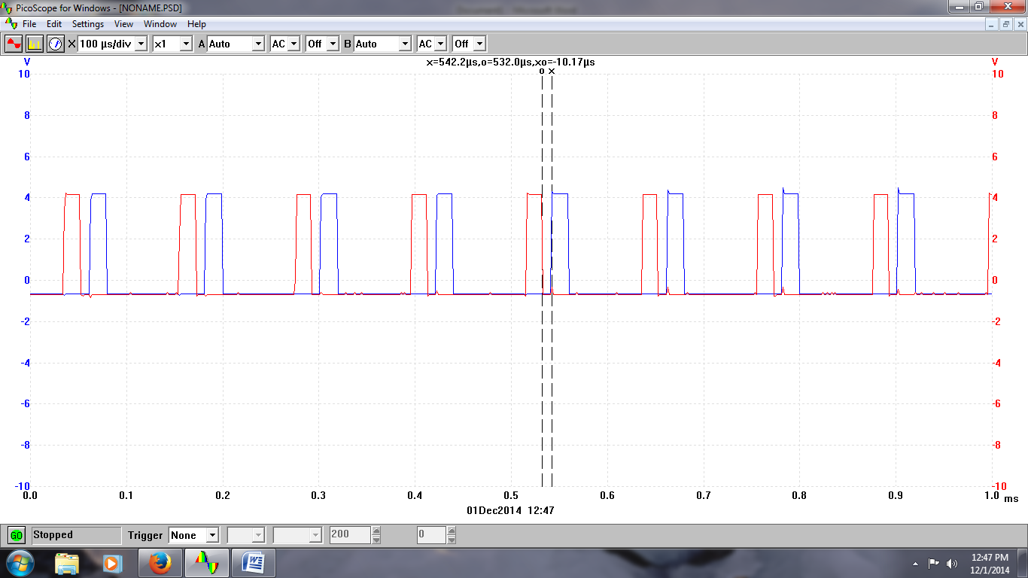

Fig 03: Channel 1 to channel 2 output at 10µs delay

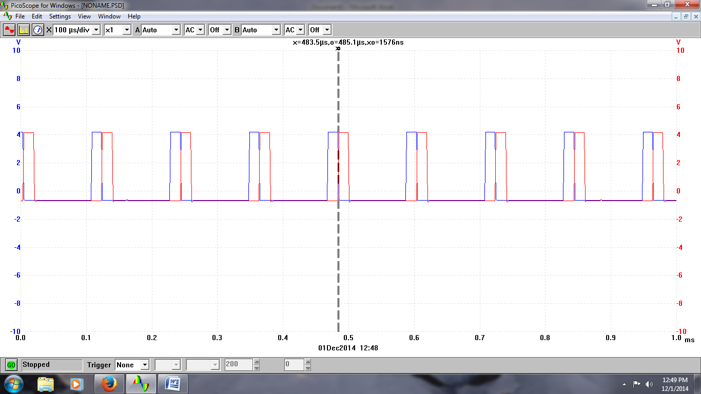

Fig 04: Channel 1 output before aliasing

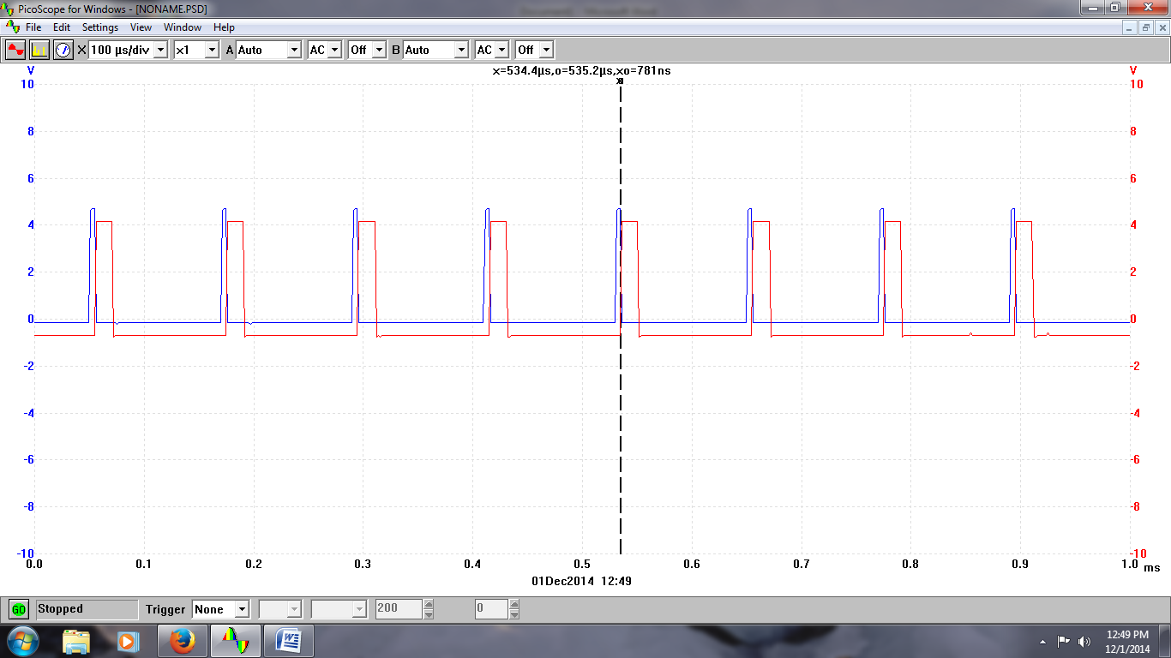

Fig 05:At minimum delay control

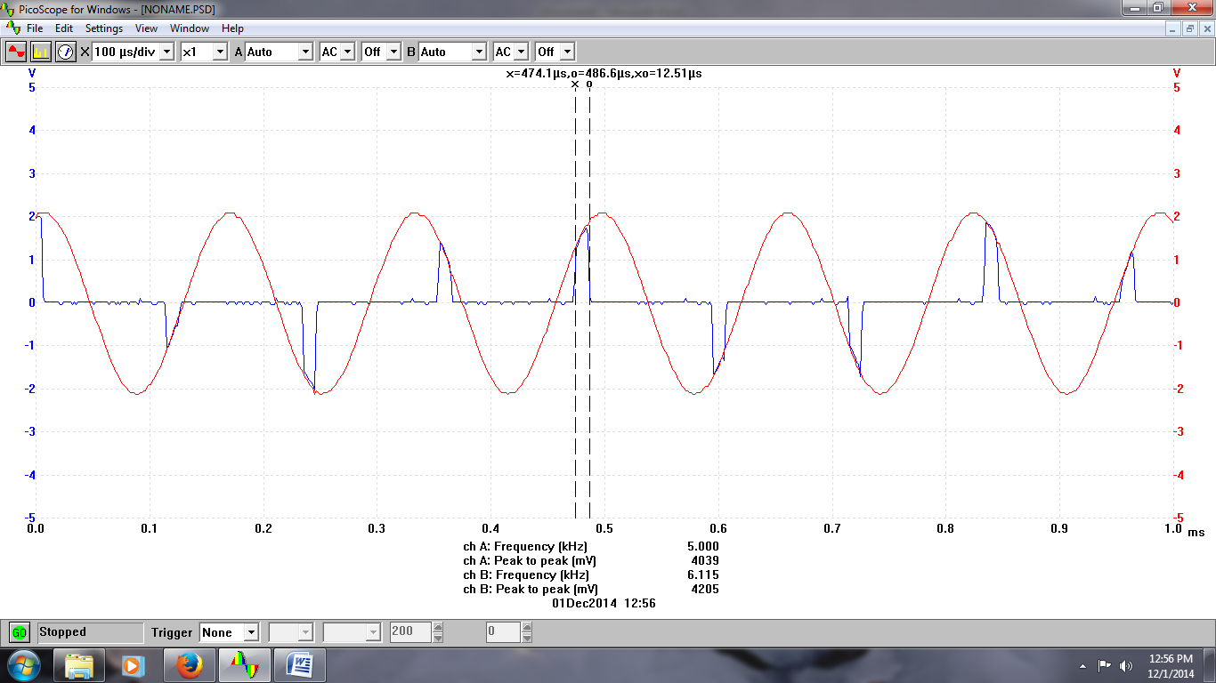

Fig 06: Sampled output for Del t at 12 microsecond

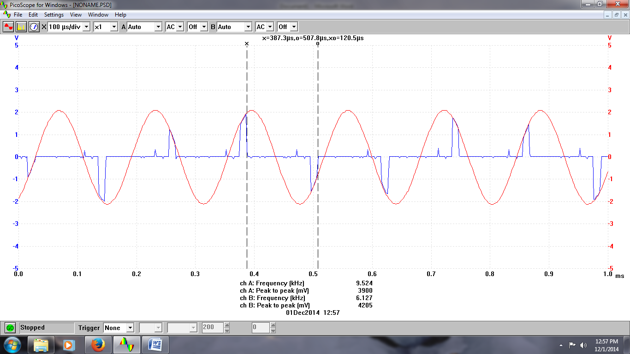

Fig 07: Sampled output for Time period at 120 micro

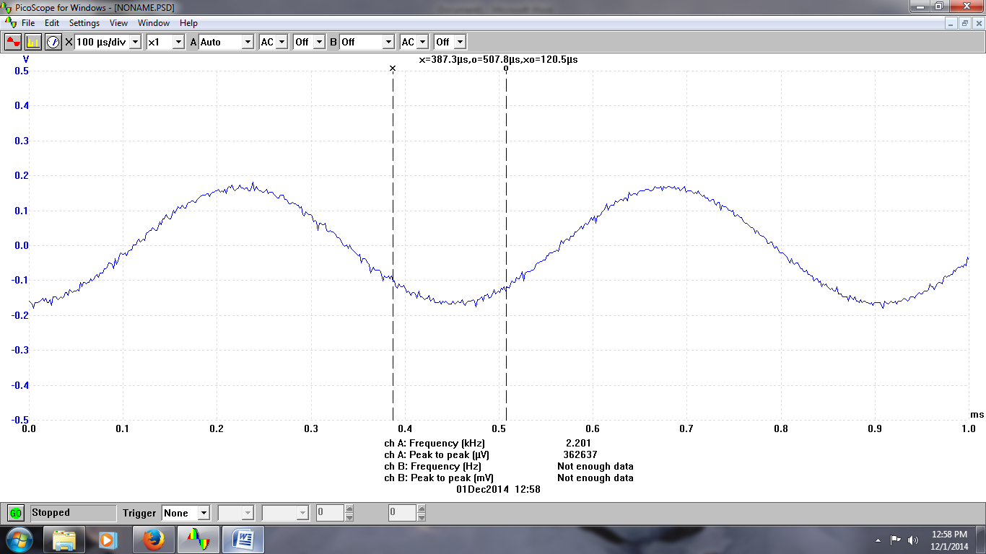

Fig 08: Reconstructed message signal

**Answer to the post-lab report questions:**

**Answer to the question no.01:**

clc

clear all;

t=-.0010:.000001:.0010;

%message signal

m_t=2*cos(6000*pi*t) + 2*cos(4000*pi*t);

plot(t,m_t)



Plot 01: Message signal in time domain

**Answer to the question no.02:**



Plot 02: Re-drawn sampled output at t=1ms

Here,

Sampling frequency, fs= 8.33Khz=(8.33×103) Hz

Sampling Period, Ts=1/fs= 1/(8.33×103) s

= 120µs

t= 1ms=10-3s

Number of samples per period, N=t/Ts= 10^-3/(120×10-6)≈8

**Answer to the question no.03:**

In TDM signal, if we increase the pulse width of the twin pulse generator, then we can recover the reconstructed message signal more easily. With the increase of Tw, the message signal will be easily observable. If we increase the pulse width then the value of Tg will decrease. We can’t increase Tw indefinitely because if we continue increasing, then at one instant there will be overlapping between the signals. If we increase Tw until Tg=0, then aliasing will occur and we can’t find the main signal.

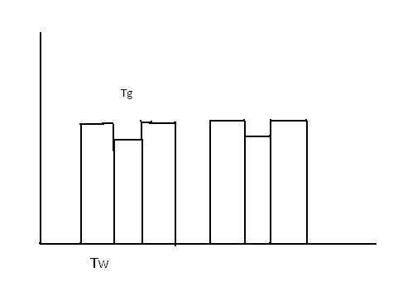

Fig 09: Sampled output when Tw is small



Fig 10: Sampled output when Tw is extented

**Answer to the question no.04:**

If we increase the spacing between the pulses, then the number of samples will decrease as the value of Tg will increase.

**Answer to the question no.05:**

For our experiment, Ts=120.5µs

Tw= 12.51µs

Tg= 791ns

N= Ts/(Tg+Tw) ≈ 9

**Answer to the question.no.06:**

Examples of telecommunication technologies are given below:

* The [plesiochronous digital hierarchy](http://en.wikipedia.org/wiki/Plesiochronous_digital_hierarchy) (PDH) system, also known as the [PCM](http://en.wikipedia.org/wiki/Pulse-code_modulation) system, for digital transmission of several telephone calls over the same four-wire copper cable ([T-carrier](http://en.wikipedia.org/wiki/T-carrier) or [E-carrier](http://en.wikipedia.org/wiki/E-carrier)) or fiber cable in the circuit switched digital telephone network
* The [synchronous digital hierarchy (SDH)/synchronous optical networking (SONET)](http://en.wikipedia.org/wiki/Synchronous_optical_networking) network transmission standards that have replaced PDH.
* The [Basic Rate Interface](http://en.wikipedia.org/wiki/Basic_Rate_Interface) and [Primary Rate Interface](http://en.wikipedia.org/wiki/Primary_Rate_Interface) for the [Integrated Services Digital Network](http://en.wikipedia.org/wiki/Integrated_Services_Digital_Network) (ISDN).
* The [RIFF](http://en.wikipedia.org/wiki/RIFF_%28File_format%29) (WAV) audio standard interleaves left and right stereo signals on a per-sample basis
* The left-right channel splitting in use for [stereoscopic](http://en.wikipedia.org/wiki/Stereoscopic) liquid crystal shutter glasses

TDM can be further extended into the [time division multiple access](http://en.wikipedia.org/wiki/Time_division_multiple_access) (TDMA) scheme, where several stations connected to the same physical medium, for example sharing the same [frequency](http://en.wikipedia.org/wiki/Frequency-division_multiplexing) channel, can communicate. Application examples include:

* The [GSM](http://en.wikipedia.org/wiki/Global_system_for_mobile_communications) telephone system
* The Tactical Data Links [Link 16](http://en.wikipedia.org/wiki/Link_16) and [Link 22](http://en.wikipedia.org/wiki/Link_22)

**Conclusion:**  In this experiment, we have learned about two modulation schemes such as PAM and TDM. We have also learned the difference between PAM and TDM. We have mostly learned about the generation of the PAM and TDM signals and the effects of increasing pulse width. We learned about the conditions of aliasing and overlapping.

**References:**

**•** J.G.Proakis and M.Salehi, Communication System Engineering, 2nd Edition, Pearson Education, Inc.,Delhi,India,2004

**•** http://en.wikipedia.org/wiki/Time-division_multiplexing