**Objective:** The objective of this experiment is to get familiar with the FM signal generation system by using a VCO (Voltage Controlled Oscillator) which is an integrated circuit. By varying the frequency of the VCO we can observe the different wave shapes of the required signal.

**Circuit Diagram:**

**Block Diagram:**



Fig 01: Generation of FM signal

**Module Connection:**

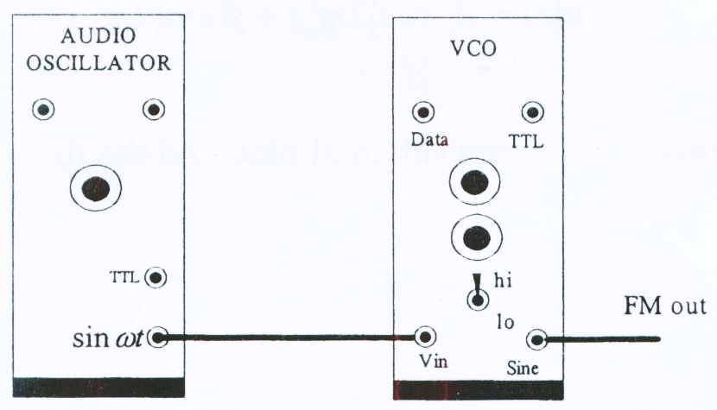

Fig 02: Module Connection for FM Generation

**Experimental Results:**

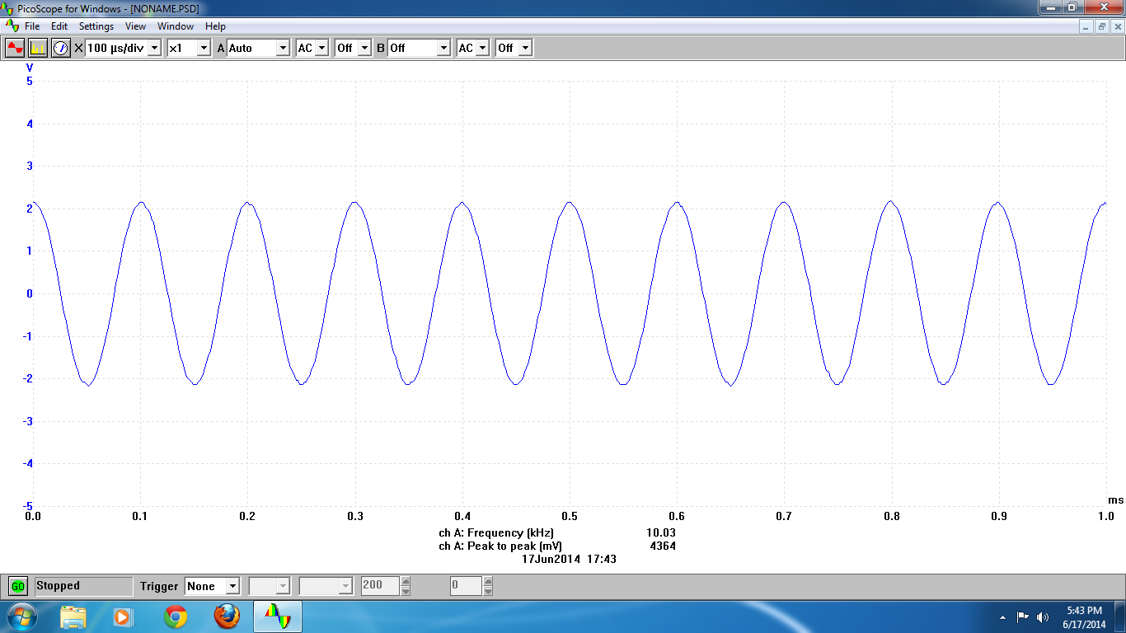

Fig 03: Message signal m(t)

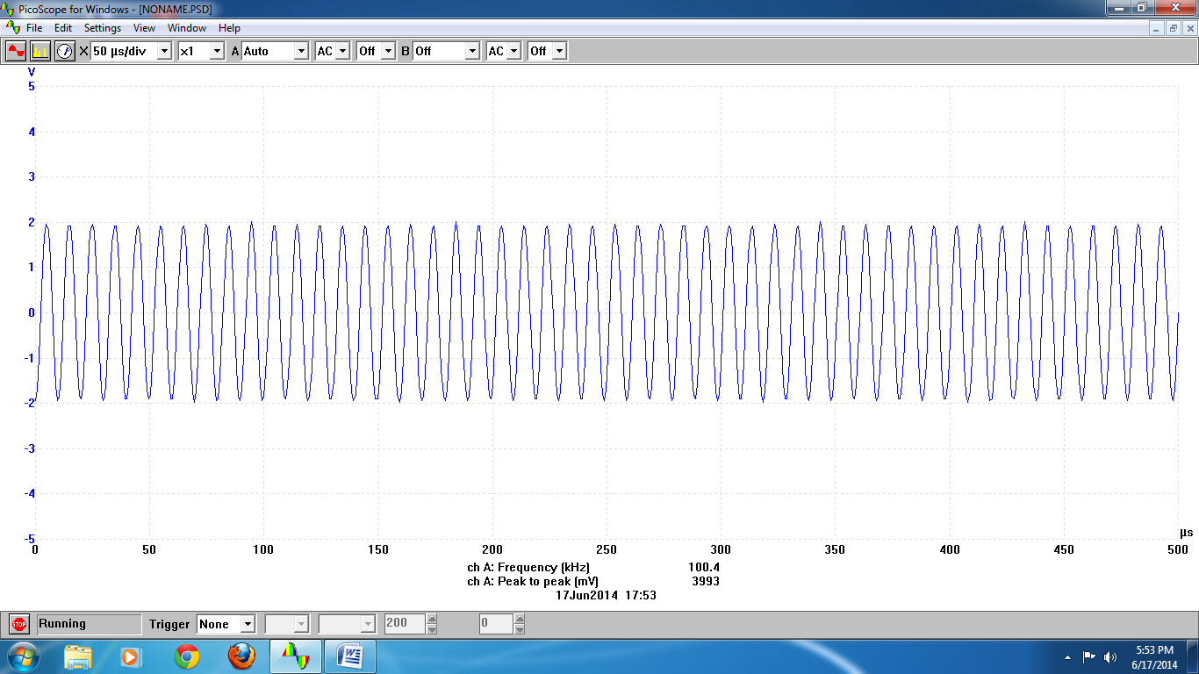

Fig 04: Carrier signal c(t)

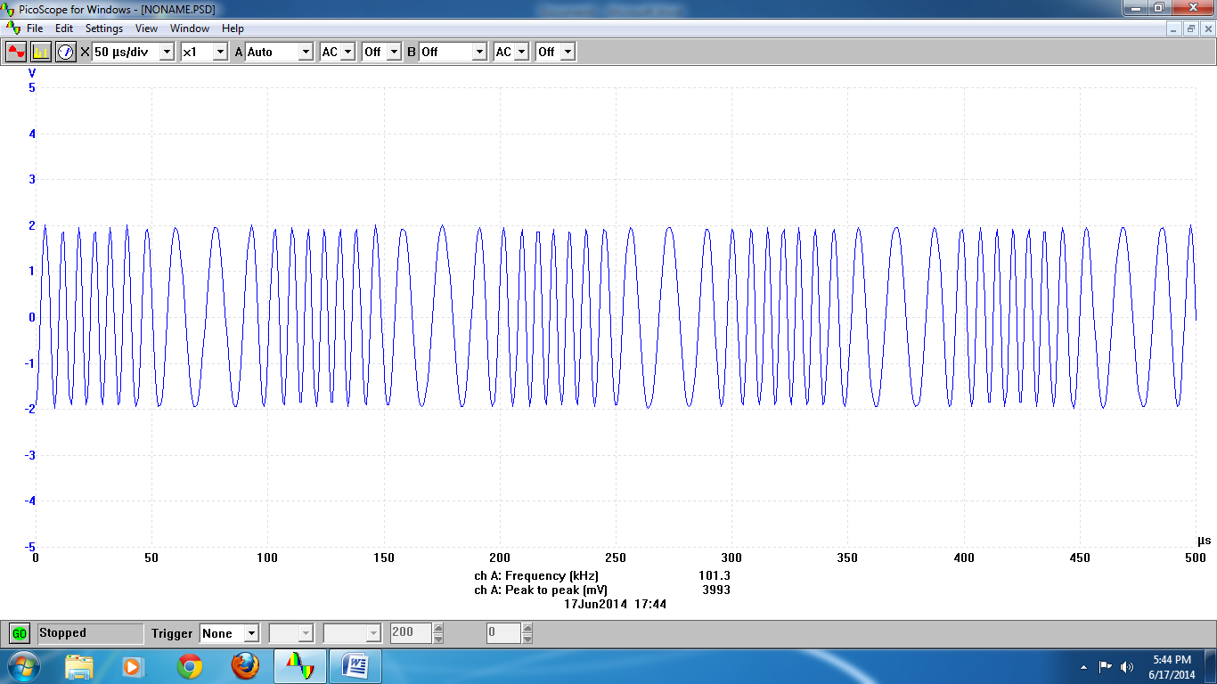

Fig 05: Modulated signal u(t)

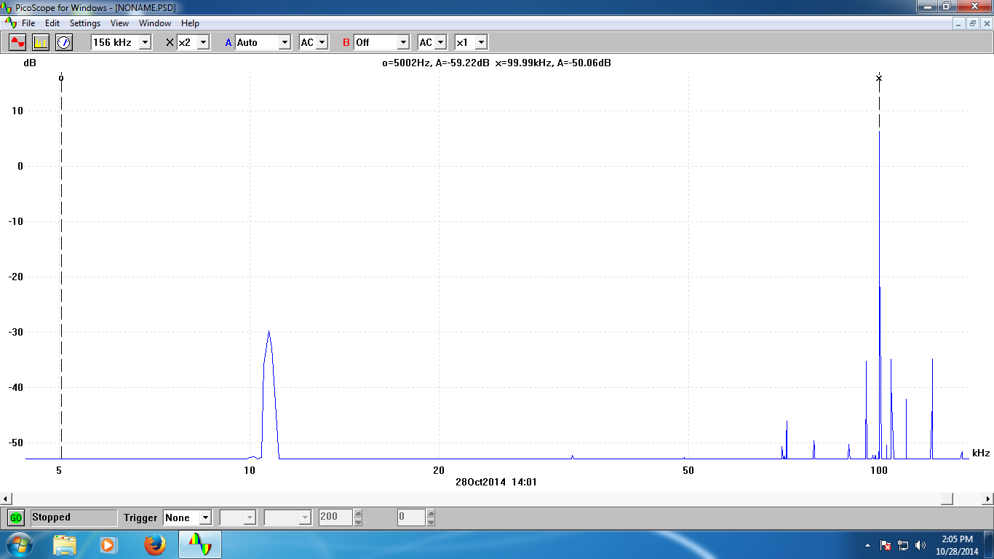

Fig 06: Spectrum of Modulated signal U(f) at fc=100KHz

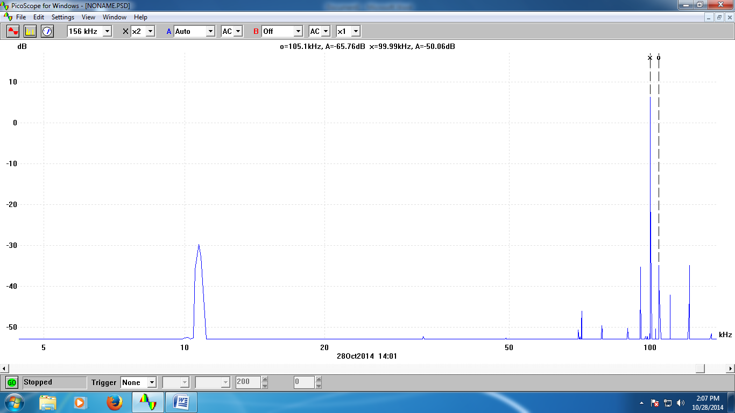

Fig 07: Spectrum of Modulated signal U(f) at fc+fm=105KHz

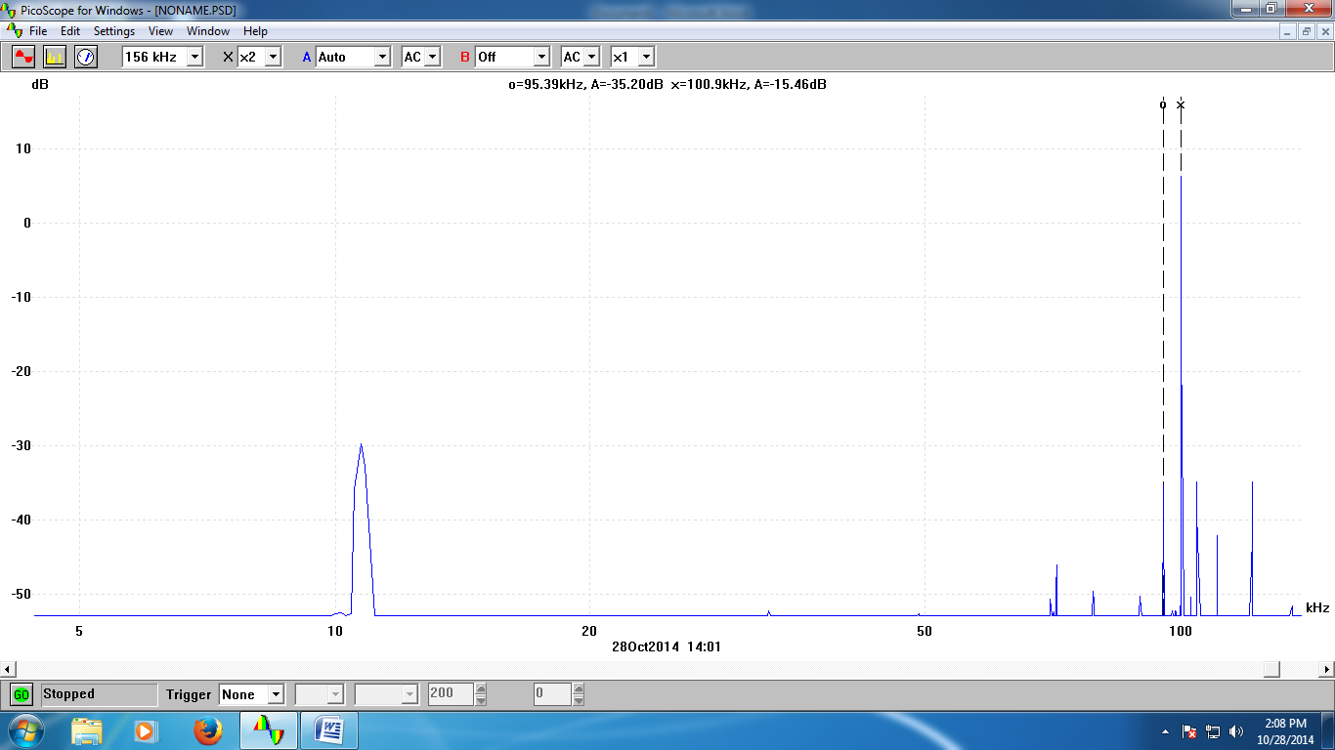

Fig 08: Spectrum of Modulated signal U(f) at fc-fm=95KHz

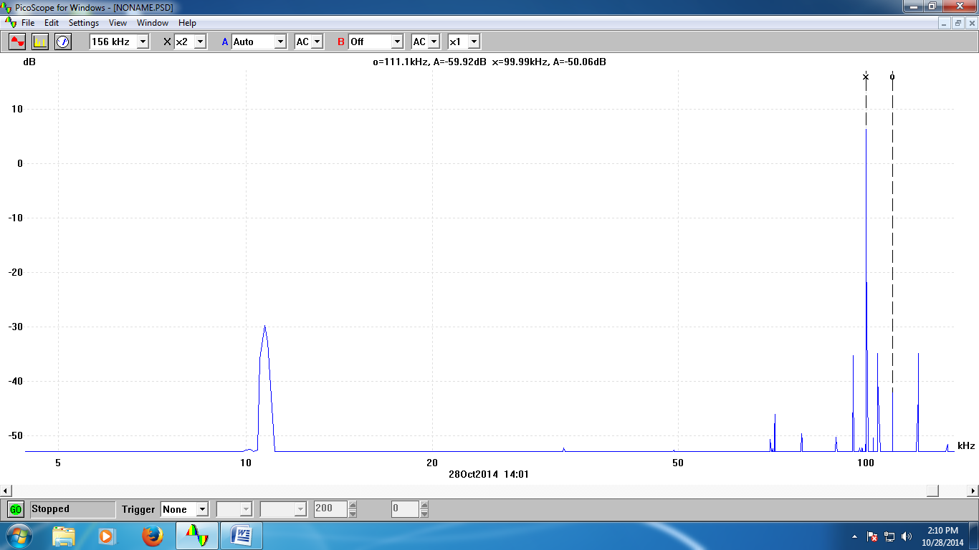

Fig 09: Spectrum of Modulated signal U(f) at fc+2fm=111KHz

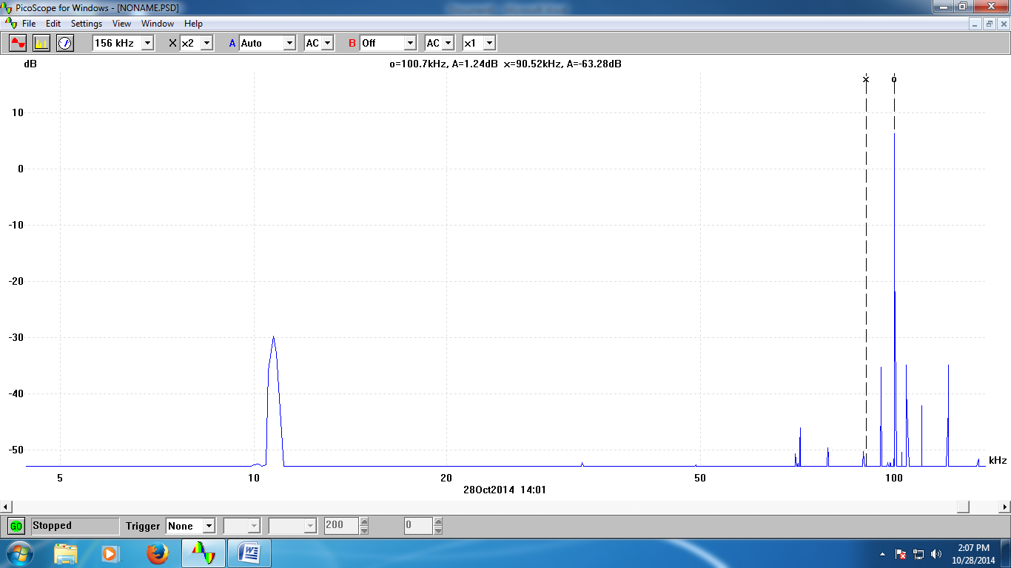

Fig 10: Spectrum of Modulated signal U(f) at fc-2fm=90KHz

**Experimental Data:**

**Table 01: Showing all the experimental values of frequency and voltage amplitudes for the multiples of fm:**

|  |  |  |
| --- | --- | --- |
| Frequency (using fc+nfm, n=integer values) | Frequency  (KHz) | Voltage amplitude  (dB) |
| fc | 100KHz | -50.06dB |
| fc+ fm | 105KHz | -65.76dB |
| fc-fm | 95KHz | -35.20dB |
| fc+2fm | 111KHz | -59.92dB |
| fc-2fm | 90KHz | -63.28dB |

From the above results, we can observe that we have found the voltage amplitudes at n=0,±1,±2. We have also found voltages at n=5 &7 but didn’t get the same for negative values of n. Thus, we ignored those frequency spectrum.

***Answers to the Lab-Report questions:***

***Answer to the question.no-01***

From the plot, Carrier signal amplitude, Ac=3.93/4=0.9825V

From the experimental data we have got the multiples of fm at n=0, 0,±1,±2,

**At n=0, fc+nfm=fc=100khz,**

|U(f)|= Ac/2 Jn(β)

Or, 10-50.06/20= 0.9825* Jn(β)

Or, Jn(β)=0.0032

**From the table of Bessel function:**

Jn(1.7)= 0.0033

Thus, β≈1.7

**At n=1, fc+nfm=fc=105khz,**

|U(f)|= Ac/2 Jn(β)

Or, 10-65.76/20= 0.9825* Jn(β)

Or, Jn(β)=0.000524

**From the table of Bessel function:**

Jn(2.6)= 0.00052

Thus, β≈2.6

**At n=-1, fc+nfm=fc=95khz,**

|U(f)|= Ac/2 Jn(β)

Or, 10-35.20/20= 0.9825* Jn(β)

Or, Jn(β)=0.0176

**From the table of Bessel function:**

Jn(1.7)= 0.0188

Thus, β≈1.7

**At n=2, fc+nfm=fc=111khz,**

|U(f)|= Ac/2 Jn(β)

Or, 10-59.92/20= 0.9825* Jn(β)

Or, Jn(β)=0.00102

**From the table of Bessel function:**

Jn(1.9)= 0.0009

Thus, β≈1.9

**At n=-2, fc+nfm=fc=90khz,**

|U(f)|= Ac/2 Jn(β)

Or, 10-63.28/20= 0.9825* Jn(β)

Or, Jn(β)=0.00068

**From the table of Bessel function:**

Jn(3.1)= 0.0006

Thus, β≈3.1

Approximate values of ,β = $\frac{1.7+1.9+2.6+1.7+3.1}{5}$

= $\frac{11}{5}$

= 2.2

***Answer to the question.no-02***

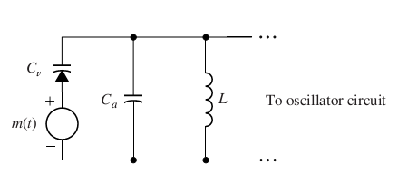

Fig (3) : Basic circuit of a VCO (implementing the Varactor diode)

At the time when $m\left(t\right)=0$, the frequency of a tuned circuit is- $f_{c}=\frac{1}{2π\sqrt{L_{0}C_{0}}}$; [using C(t) = C0 + k0m(t) as , so C(t) = C0]

Now using a non zero $m\left(t\right)$ [$m\left(t\right)≠0$]; we have –

M (t), we have

$$f_{i}\left(t\right)=\frac{1}{2π\sqrt{L_{0}\left(C_{0}+k_{0}m\left(t\right)\right)}}$$

$$=\frac{1}{2π\sqrt{L_{0}C_{0}}}\frac{1}{\sqrt{1+\frac{k_{0}}{C_{0}}m(t)}}$$

$$=f_{c}\frac{1}{\sqrt{1+\frac{k_{0}}{C_{0}}m(t)}}$$

Assuming that $$ε=\frac{k_{0}}{C_{0}}m\left(t\right)≪1$$

And using the approximations

$$\sqrt{1+ε} ≈1+\frac{ε}{2}$$

$$\frac{1}{1+ε} ≈1-ε$$

We obtain

$$f_{i}\left(t\right)≈f_{c}\left(1-\frac{k_{0}}{2C_{0}}m(t)\right)$$

***Answer to the question.no-03***

clear all;

Ac=1.965;

fc=99000;

fm=10300;

B=1.1;

t=0:1e-6:1e-3;

m=4.3*cos(2*pi*fm.*t); %Message signal

u_1=0;

for n=-7:7

u_1=u_1+Ac*besselj(n,B)*cos(2*pi.*t*(fc+(n*fm)));

end

u_2=Ac*cos((2*pi*fc.*t)+(B*sin(2*pi*fm.*t)));

%% plot for the u_1

subplot(2,1,1)

plot(t,u_1)

hold on

plot(t,m)

% plot for the u_2

subplot(2,1,2)

hold on

plot(t,m)

plot(t,u_2)



Plot 01: FM signals for u1(t)=AcJn(β)cos2π(fc+nfm)t and u2(t)=Accos[2πfct+βsin(2πfmt)]

**Conclusion:** In this experiment, we have observed angle modulation of FM signal generation and proved that in FM angle modulation, we can found spectrum at the multiples of fm signal. This experiment has been encountered by the use of a Voltage controlled oscillator in TIMS module. We have also learned how to calculate β from Jn(β) using the table of Bessel function. Β is the modulation index on which the power of the modulated signal depends on. The spectral lines corresponding to the positive values of n are called the upper sidebands and negative values of n are called the lower sidebands. We have also wrote a MATLAB code to show that the theoretical and experimental results are same.

**References:**

• J.G.Proakis and M.Salehi, Communication System Engineering, 2nd Edition, Pearson Education, Inc.,Delhi,India,2004.

• http://zimmer.fresnostate.edu/~pkinman/pdfs/Frequency%20Modulation.pdf

• <http://www.d.umn.edu/~ibra0130/a1-10a.pdf>

**Appendix A: IEEE format of Bessel Function:**

