**EAST WEST UNIVERSITY**

Department of Electrical and Electronic Engineering

EEE 307 : Telecommunication Engineering

**Experiment No 04: Sampling**

**Submitted by**

[Puja Pandit]

[2012-1-85-014]

Group no: 03

Group Members name: Puja Pandit ID: 2012-1-85-014

Atika Mansur Nirzona ID: 2012-1-80-045

Md. Mozahedul Islam ID: 2012-1-80-003

Nishat Khan Rimi ID: 2012-1-80-027

Shohanur Rahman ID: 2012-1-80-012

Sheikh Md. Razoan ID: 2010-2-80-035

Course Instructor: MBS

Date of performance: 18.11.2014

Date of submission: 25.11.2014

**Objective:** The objective of this experiment is to know how to sample the given message signal for a given sampling frequency at least twice of the message frequency.

**Circuit Diagram:**



Figure 01: An Analog Sampler



Figure 02: Four Samples per period of a sine wave

**Reconstruction:**



Figure 03: Reconstruction Circuit

**Module Connection:**

Figure 04: Module connection for sampling and reconstruction of message signal

**Experimental Results:**

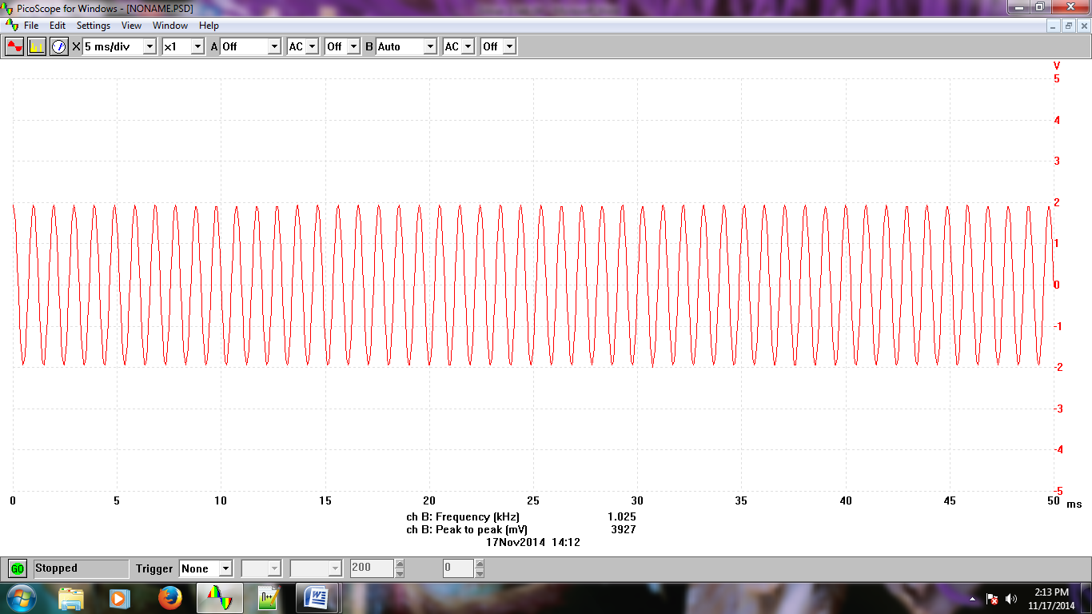

Figure 05: Message Signal m(t)

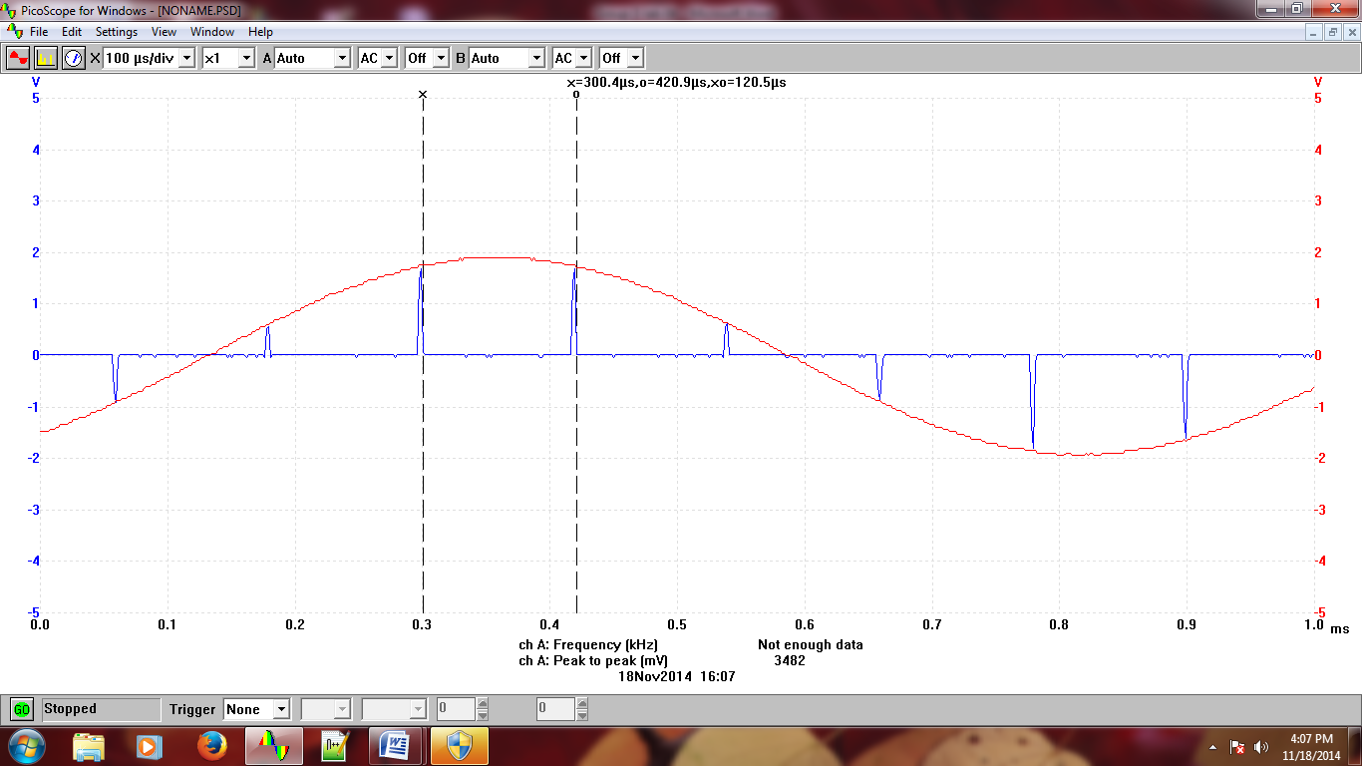

Figure 06: Sampled signal at fs=8.33kHz with message frequency, fm=1KHz

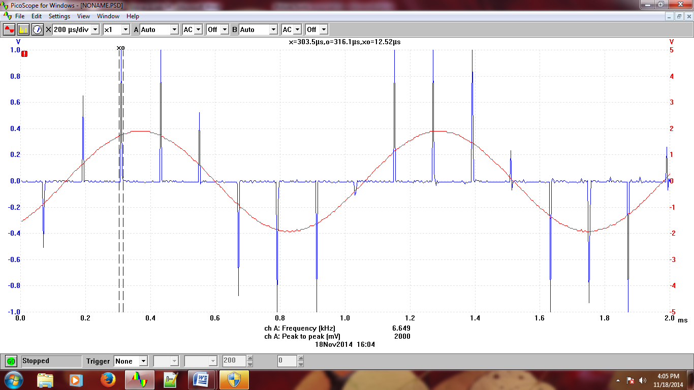

Figure 07: Sampled signal at fs=8.33kHz with fm=1KHz where ∆t=1/10 of Ts

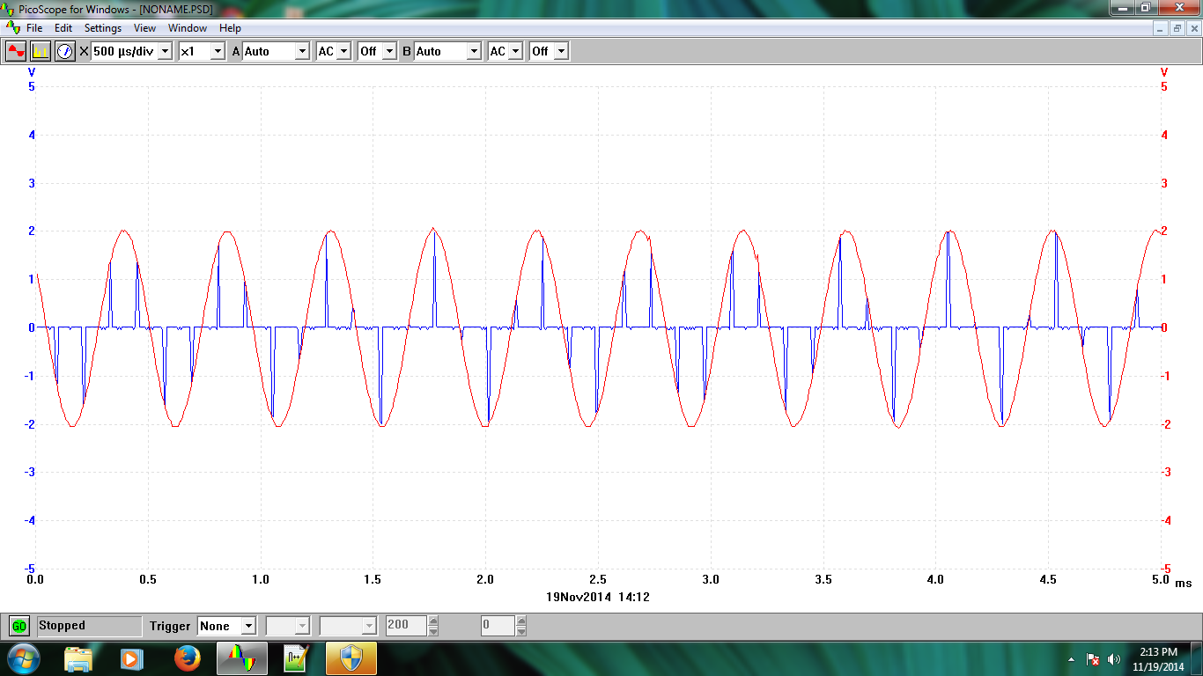

Figure 08: Sampled signal with message frequency fm=2KHz

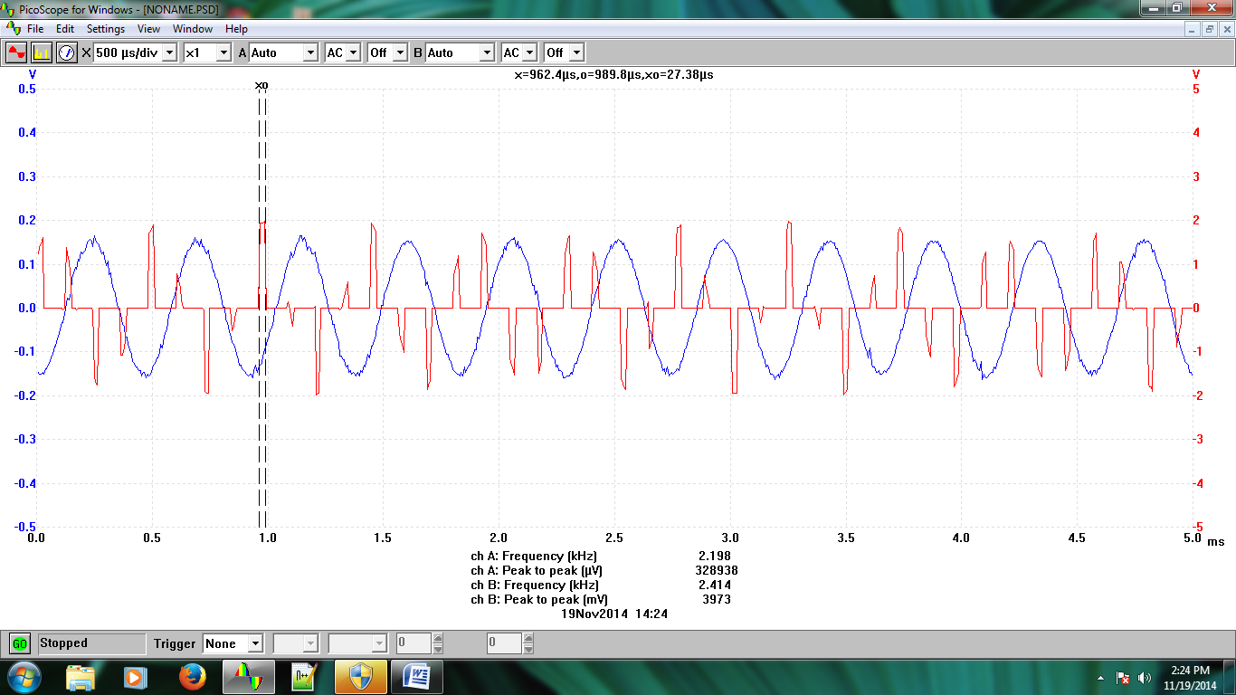

Figure 09: Output of the reconstruction filter after reinstating AUDIO OSCILLATOR

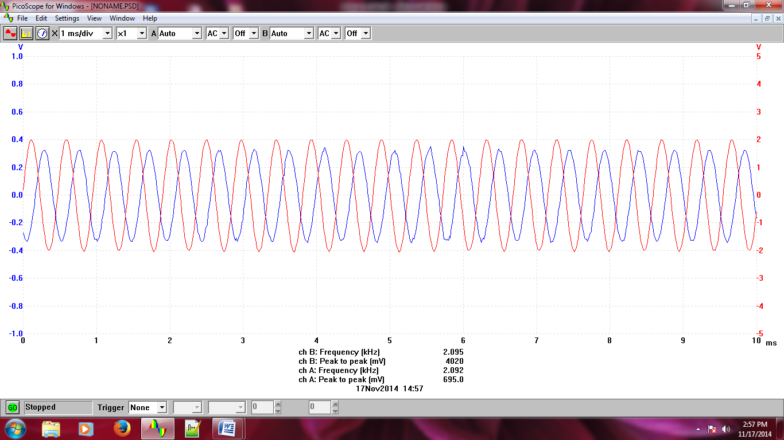

Figure 10: Reconstructed Signal for varying del(t) using twin pulse generator width switch

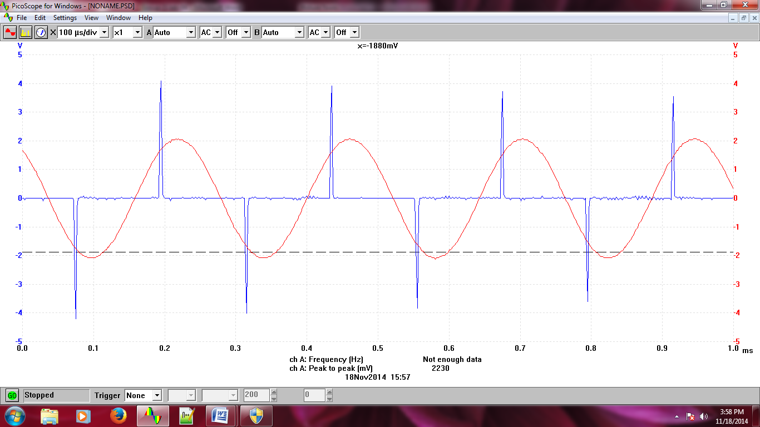

Figure 11: Reconstructed signal when fm=4.13khZ which is ½ of the fs

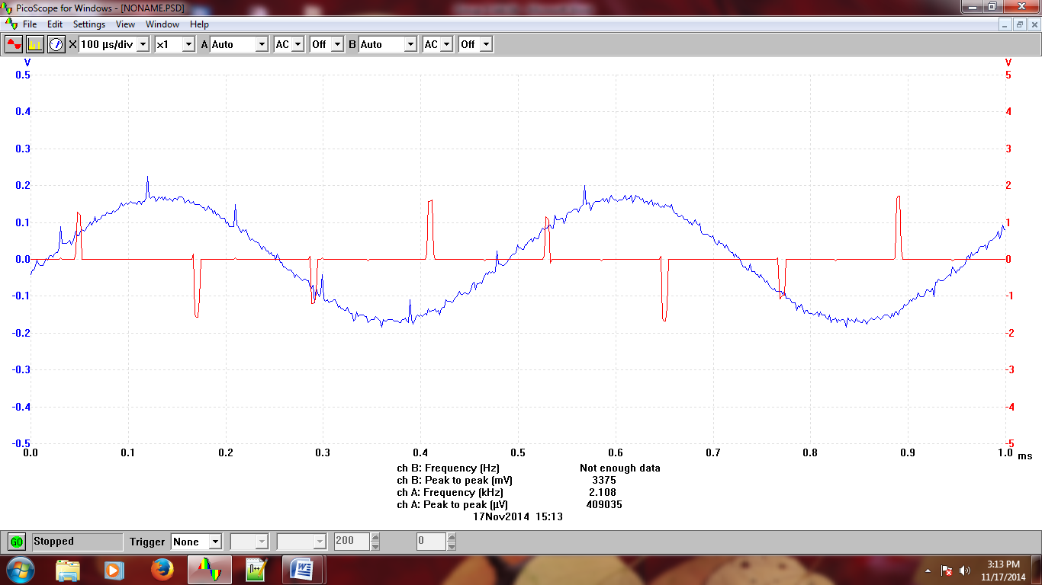

Figure 12: Reconstructed signal for varying fm, sampling width, bandwidth of the signal

**Answers to the post-lab report questions:**

***Answer to the question No. 01(a):***

Given, m(t)=2cos(SID)2πt+6sin(5*SID)πt+10cos(π/6+(7*SID)πt)

My student is 2012-1-85-014 and the last 2 digit of my ID is 14. Setting SID=14, we can get the message signal in time domain.

**Matlab Code for drawing the message signal in time domain:**

clc

clear all

%student id=2012-1-85-014

SID=14;

t=-0.1:.00000001:0.1;

m_t=2*cos(2*pi*SID*t)+6*sin(5*pi*SID*t)+10*cos(7*pi*SID*t+(pi/6));

plot(t,m_t);



Plot 01: Message signal m(t) in time domain using MATLAB

***Answer to the question No. 01(b):***

From the given equation of m(t)=2cos(SID)2πt+6sin(5*SID)πt+10cos(π/6+(7*SID)πt), we can see that the highest value of frequency components is 7/2*SID=3.5*14=49KHz

Thus, fm=W=49KHZ

So, the Nyquist rate in this case will be 2fm= (2×98) =98KHZ

**MATLAB Code for the sampled m(t) at Nyquist Rate:**

|  |  |  |  |
| --- | --- | --- | --- |
| |  |  |  | | --- | --- | --- | | |  | | --- | |  | |  |   clc clear all           %student id=2012-1-85-014 SID=14; t=-.06:.0001:.06; m_t=2*cos(2*pi*SID*t)+6*sin(5*pi*SID*t)+10*cos(7*pi*SID*t+(pi/6)); fm=3.5*SID; %Nyquist sampling rate fs=2*fm; %sampling period ts=1/fs; t1=-.1:ts:.1; s_t=2*cos(2*pi*SID*t1)+6*sin(5*pi*SID*t1)+10*cos(7*pi*SID*t1+(pi/6)); plot(t,m_t) hold on stem(t1,s_t) |



Plot 02: Sampled signal at Nyquist rate

***Answer to the question No. 01(c):***

**MATLAB Code for the sampled signal for two sampling period:**

clc

clear all

%student id=2012-1-85-014

SID=14;

t=-.06:.0001:.06;

m_t=2*cos(2*pi*SID*t)+6*sin(5*pi*SID*t)+10*cos(7*pi*SID*t+(pi/6));

fm=3.5*SID;

%Nyquist sampling rate

fs=2*fm;

%sampling period

ts=1/fs;

t1=ts:ts:2*ts;

s_t=2*cos(2*pi*SID*t1)+6*sin(5*pi*SID*t1)+10*cos(7*pi*SID*t1+(pi/6));

plot(t,m_t)

hold on

stem(t1,s_t)



Plot 03: Sampled output for two sampling period

***Answer to the question No. 01(d):***

clc

clear all

%student id=2012-1-85-014

SID=14;

t=-.06:.0001:.06;

m_t=2*cos(2*pi*SID*t)+6*sin(5*pi*SID*t)+10*cos(7*pi*SID*t+(pi/6));

fm=3.5*SID;

%Nyquist sampling rate

fs=2*fm;

%sampling period

ts=1/fs;

t1=-.1:ts:.1;

s_t=2*cos(2*pi*SID*t1)+6*sin(5*pi*SID*t1)+10*cos(7*pi*SID*t1+(pi/6));

q_r=round(s_t);

plot(t1,q_r)

hold on

stem(t1,s_t)



Plot-04: Quantizer output for the given message signal

***Answer to the question No. 01(e):***

From the quantizer output signal we can observe that there are 12 levels. That means, L=12

Thus we can calculate the number of bits from L=2n-1

12=2n-1

Or, 12+1=2n

Or, 13=2n

Or, log10(13)=nlog102

Or, n= log10(13)/ log102= 3.7≈4

So, the number of bits to represent a single level is n=4

**The output (SQNR)0**

10log10(SQNR)0 = 1.8+20log10L

(SQNR)0 = 1.8+6n

= 25.8dB

***Answer to the question No. 02:***

The input to an analog-to-digital converter (ADC)consists of a [voltage](http://searchcio-midmarket.techtarget.com/definition/voltage) that varies among a theoretically infinite number of values. the input signal is processed with an electronic low-pass filter to remove all frequencies above the Nyquist frequency (one-half the sampling rate). This is done to prevent aliasing during sampling, and is correspondingly called an antialias filter. On the other end, the digitized signal is passed through a digital-to-analog converter and another low-pass filter set to the Nyquist frequency. Examples are sine waves, the waveforms representing human speech, and the signals from a conventional television camera. The output of the ADC, in contrast, has defined levels or states. The number of states is almost always a power of two i.e 2, 4, 8, 16, etc. The simplest digital signals have only two states, and are called [binary](http://searchcio-midmarket.techtarget.com/definition/binary). All whole numbers can be represented in binary form as strings of ones and zeros. Three types of analog filters are commonly used: Chebyshev, Butterworth and Bessel.

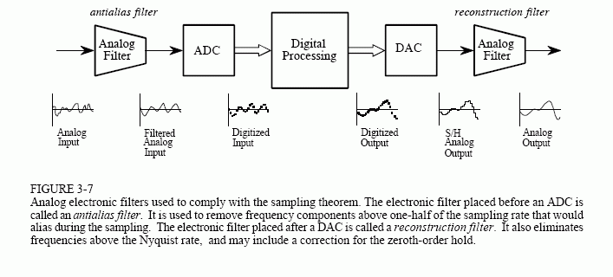

Fig 12: An analog to digital converter representing the conversion process of ADC

A typical telephone [modem](http://searchmobilecomputing.techtarget.com/definition/modem) makes use of an ADC to convert the incoming audio from a twisted-pair line into signals the computer can understand. In a digital signal processing system, an ADC is required if the signal input is analog.

**Conclusion:** From this experiment, we have learned the process of sampling and the conversion process from analog to digital signal. We have learned how to change the width of the twin pulse generator to change the sample clock period ∆t. We have also learned how to draw the message signal, sampled signal and quantized output from a given m(t) using MATLAB.

**References:**

**•** [**http://whatis.techtarget.com/definition/analog-to-digital-conversion-ADC**](http://whatis.techtarget.com/definition/analog-to-digital-conversion-ADC)

**•** J.G.Proakis and M.Salehi, Communication System Engineering, 2nd Edition, Pearson Education, Inc.,Delhi,India,2004.

• http://www.dspguide.com/ch3/4.htm