**Objective:** Aim of this experiment is to know about conventional AM modulation signal.

**Circuit Diagram:**

Block Diagram:



Figure 1: Generation of DSB signal

**Experimental Data:**

Table 1: Experimental data of message signal m(t) and carrier signal c(t)

|  |  |  |  |
| --- | --- | --- | --- |
| Signal | Peak-peak voltage (mV) | Peak voltage(mV) | Frequency (KHz) |
| m(t) | 2462 | 1231 | 7.462 |
| c(t) | 3946 | 1973 | 100 |

Table 2: Experimental data for the modulated signal u(t) and its Spectrum for different condition

|  |  |  |  |  |
| --- | --- | --- | --- | --- |
| Modulation index, a | Peak-peak voltage (mV) | Frequency (KHz) | fc+fm (dB) | fc-fm (dB) |
| Under modulated(a<1) | 8029 | 99.96 | -59.14 | -9.14 |
| Balance modulated(a=1) | 11106 | 77.75 | -57.12 | -57.80 |
| Over modulated( a>1) | 11106 | 87.42 | 6.46 | 5.10 |

**Answer to the lab report questions:**

**(1)Answer:**

Modulation index for under modulated signal a $=\frac{A_{max}-A_{min}}{A_{min}+A_{max}}$

=(4070-1551)/(4070+1551)=0.4481

Peak value of carrier signal (fc)= 1973mV=1.973V

Carrier signal power

20log(1.973)=dB

dB=5.9dB

10log(Power)=5.9

Power=3.89 W

The peak of the side band spectrum was : -9.14 dB

Side band Power

$10\log_{10}{y}=-9.14$ $y= {10}^{\frac{-9.14}{10}}=0.122$ W

PSD

(3.98) (3.98)

(0.122)(0.122)(0.122)(0.122)

-fc-fm -fc -fc+fm 0 fc-fm fc fc+fm

Fig.2 : PSD for under modulated signal

Modulation index for balance modulated signal a $=\frac{A_{max}-A_{min}}{A_{min}+A_{max}}$

=(5659-1)/(5659+1)=0.9996

The peak of the side band spectrum was : -57.12 dB

Side band Power

$10\log_{10}{y}=-57.12$ $y= {10}^{\frac{-57.12}{10}}=(1.94*10^-6$)W

PSD

(3.98) (3.98)

(1.94*10-6)(1.94*10-6)(1.94*10-6)(1.94*10-6)

-fc-fm -fc -fc+fm 0 fc-fm fc fc+fm

Fig3: PSD for balance modulated signal

Modulation index for over modulated signal a $=\frac{A_{max}-A_{min}}{A_{min}+A_{max}}$

=(5581+2092)/(5581-2092)=2.1992

The peak of the side band spectrum was : 6.46dB

Side band Power

$10\log_{10}{y}=6.46$ $y= {10}^{\frac{6.46}{10}}=4.4$ W

PSD

(3.98) (3.98)

(4.4)(4.4)(4.4)(4.4)

-fc-fm -fc -fc+fm 0 fc-fm fc fc+fm

Fig3: PSD for over modulated signal

**(2)Answer:**

**(3)Answer:**

MATLAB CODE:

clc

clear all

am=1;

Ac=25;

fc=2146000; %Student ID:2012-2-80-052

fm=(1/20)*fc;

t=0:.00001:.01;

m_t=am*cos(2*pi*fm*t);

c_t=Ac*cos(2*pi*fc*t);

%for a=0.5

u_t_1=[1+((0.5)*m_t)].*c_t;

subplot(3,1,1),plot(t,u_t_1)

%For a=1

u_t_2=[1+(1*m_t)].*c_t;

subplot(3,1,2),plot(t,u_t_2)

%For a=1.5

u_t_3=[1+(1.5*m_t)].*c_t;

subplot(3,1,3),plot(t,u_t_3)



**Conclusion:** The objective of this experiment was to verify the conventional DSB amplitude modulation for three conditions. Three conditions are under modulation,balabce modulation and over modulation. In the lab signal and spectrum was shown.Signal spectrum was with with two side band and carrier, which proved that this was conventional DSB AM.in the lab we used TIMS module and picoscope.

**References:**

1. J.G.Proakis and M.Salehi, *Communication Systems Enginerring*,2nd Edition, Pearson education,Inc.,Delhi,Indian2004

LAB DATA:

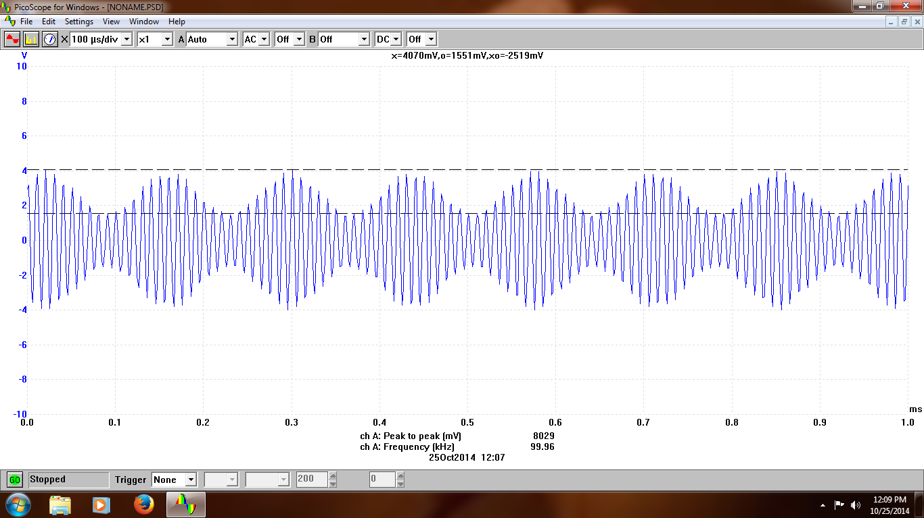

Figure 1: Under modulated signal in time domain.

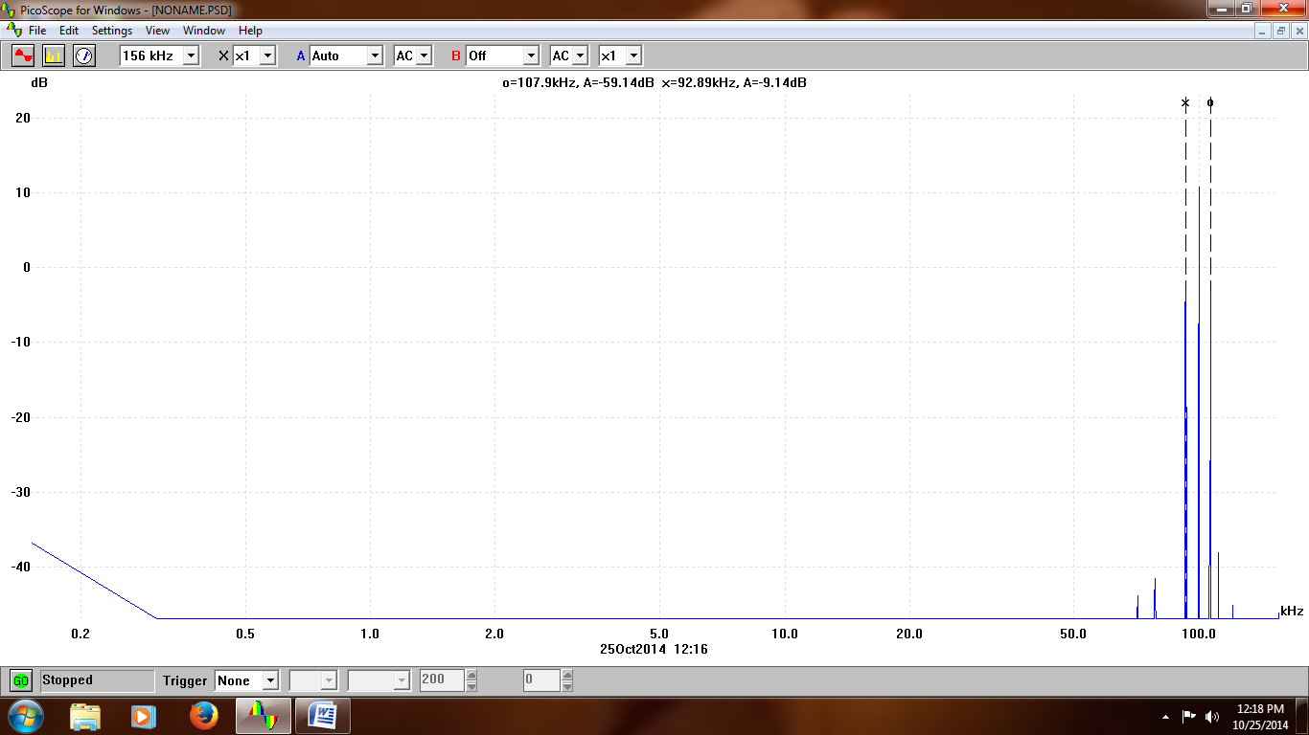

Figure 2: Under modulated signal spectrum

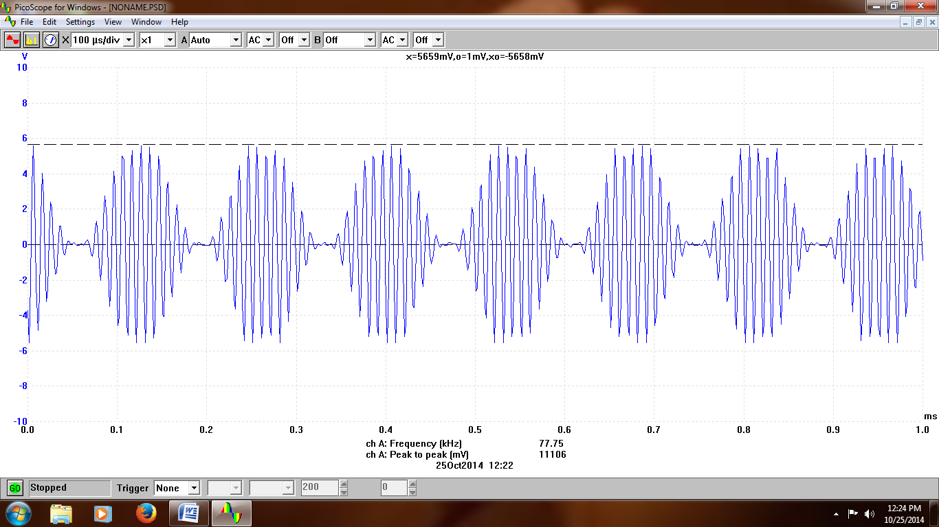

Figure 3: Balanced modulated signal in time domain .

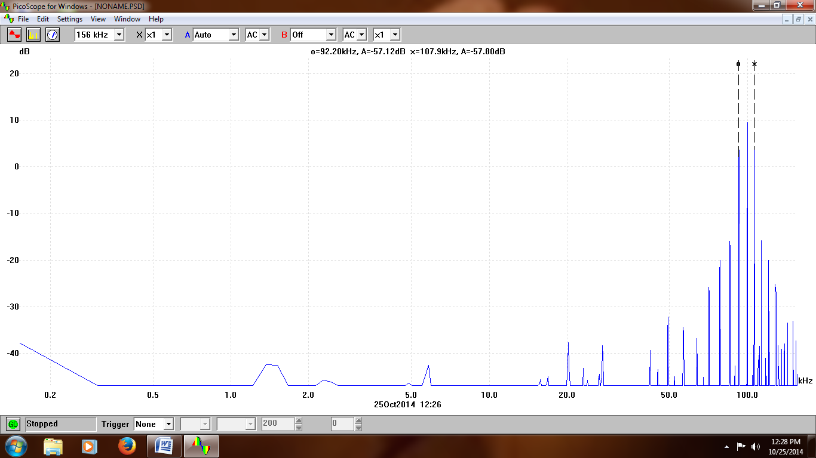

Figure 4: Balanced modulated signal spectrum.

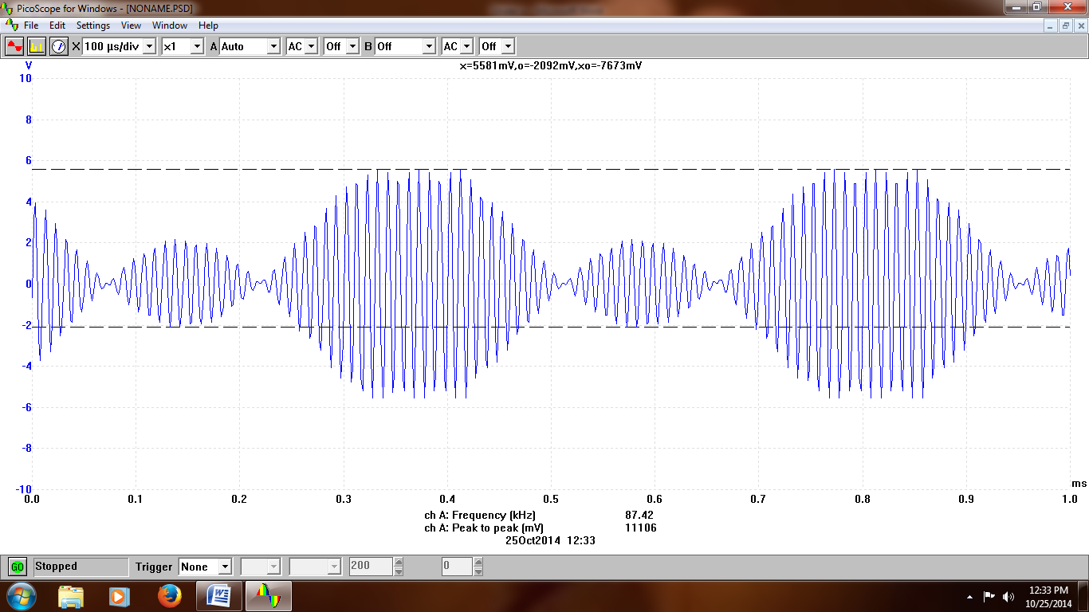

Figure 5: Over modulated signal in time domain.

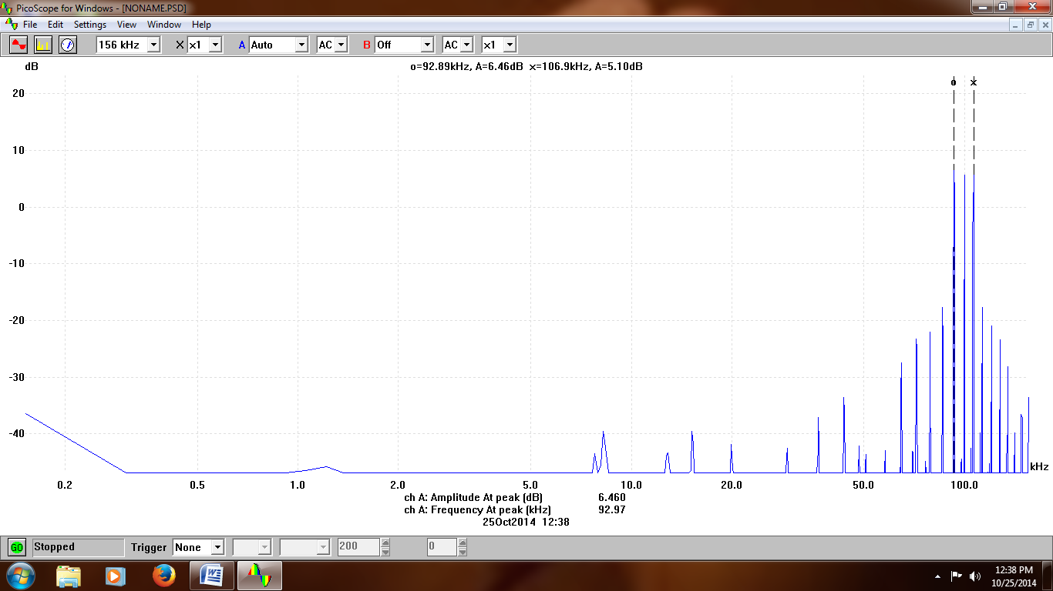

Figure 6: Over modulated signal spectrum.

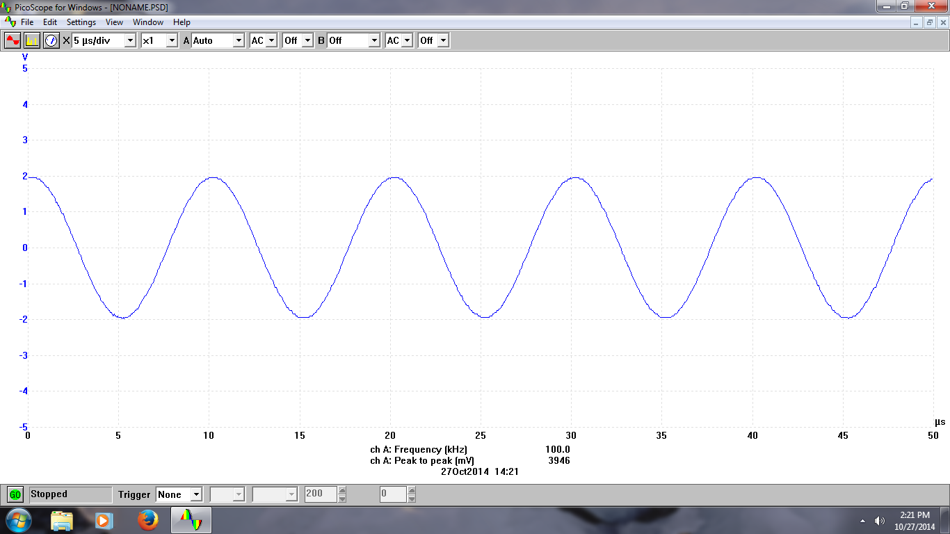

Figure 7: Carrier signal c(t)

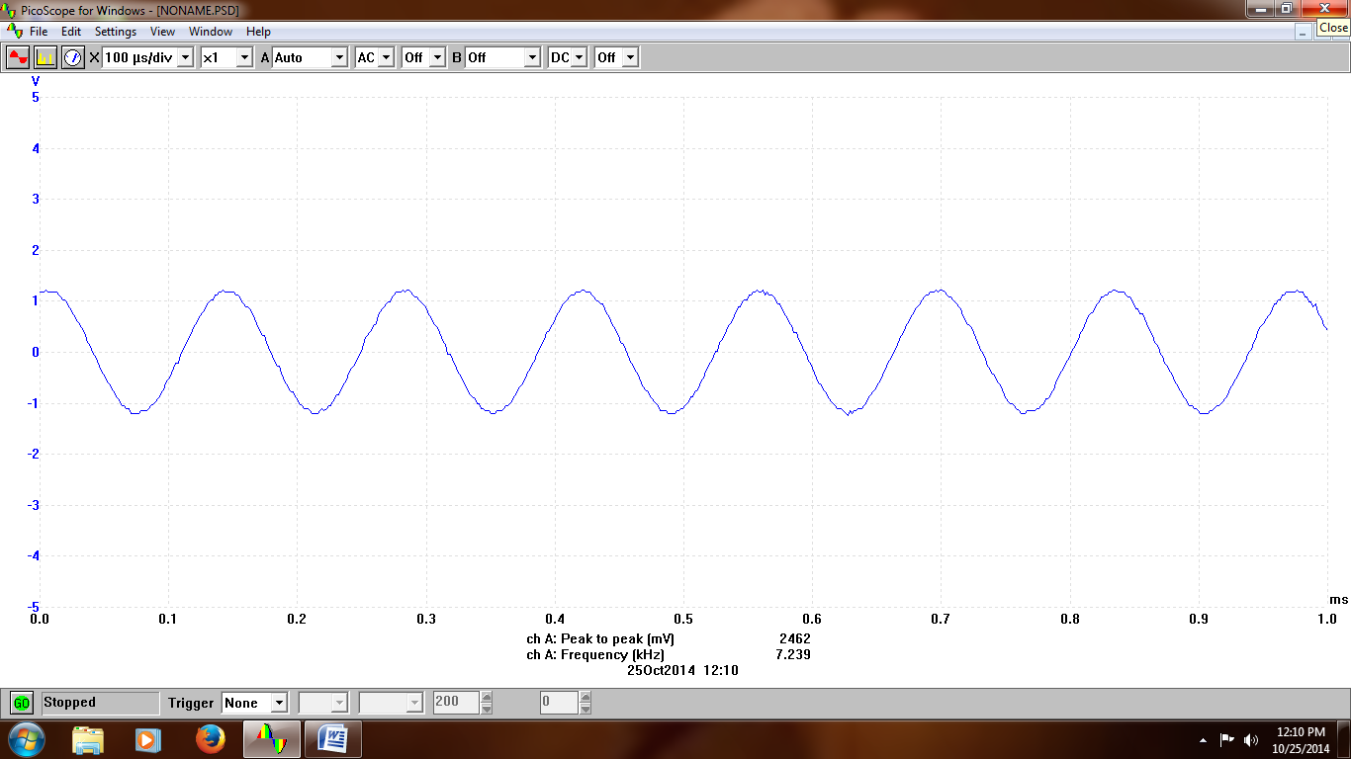

Figure 8: Message signal m(t)