Objective:

The objective of this experiment is to review the characteristics of a differential MOSFET differential pair.

Circuit Diagram:

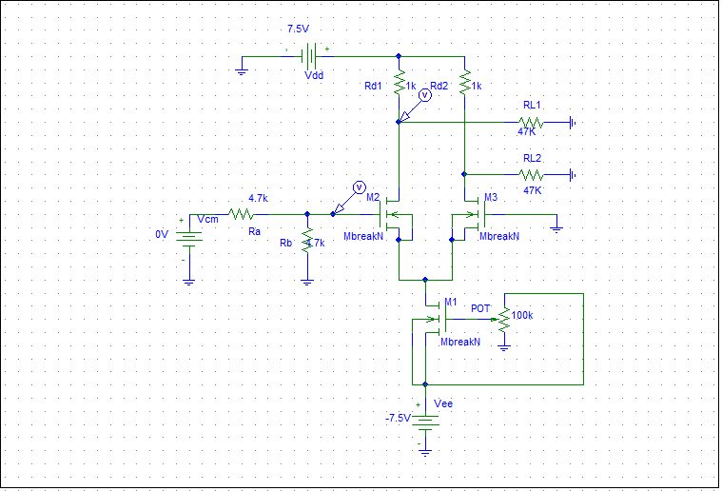

Fig 01: Schematic Diagram of the circuit that we constructed in lab.

Experimental Setup:

1.CD4007 IC – 2pcs

2.Resisrtor(1k-2pcs,4.7k-2pc,47k-2pc,10k-1pc)

Procedure:

First we have to measure the value of the resistors. Then we have to setup the circuit with proper connection. Then we have to take the measurements of the variables of datasheet. Then we have set the bias for the current source to get required current. . then we apply positive and negative Vcm to get the upper and lower value for which Vd becomes constant.

Measurements:

Part 1:

VDVM=6.45V

Vth=0.58V

ID=0.58V

VGS=6.46V

K’nW/L=33.55µA/V2.

Part 2:

Vs=-2.1V

Vd1=7.03V

Vd2=7.02V

VGS1=2.11V

VGS2=2.11V

Gm=0.588mA/V

V+ve=1.78V

Voutput=6.67V

V+ve=-1.58V

Voutput=7.25V

Answer to the question no:1

Measurement of necessary data using PSpice simulation:

|  |  |  |  |  |
| --- | --- | --- | --- | --- |
| Ra(Ω) | RL=Ra+R2(Ω) | VRL | IRL | VD_Q2 |
| 0 | 0.98k | 0.18V | 0.172mA | 4.81V |
| 3.3k | 4.29k | 0.74V | 0.172mA | 4.26V |
| 4.7k | 5.59k | 0.968V | 0.172mA | 4.03V |
| 10k | 11k | 1.77V | 0.163mA | 3.21V |
| 14.7k | 15.88k | 2.36V | 0.149mA | 2.64V |
| 25k | 25.9k | 3.12V | 0.120mA | 1.88V |

MATLAB plotting code:

clear all

VD_Q2=[4.48,2.85,2.24,0.36,0.18,0.11];

IRL=[0.5,0.49,0.49,0.42,0.30,0.18];

plot(VD_Q2,IRL);hold on ;

VDx_Q2=[4.81,4.26,4.03,3.21,2.64,1.88];

IRLx=[0.172,0.172,0.172,0.163,0.149,0.120];

plot(VDx_Q2,IRLx);

 Plot 01: Plot of ID vs V_DS using experimental data and PSpice simulated data

In the lab measured data, we can observe a dramatic change in the curve. But the PSpice gives us a very smooth curve. The fact is that, the real world devices are a little bit far from the simulation.

Answer to the question no:2

Operating temperature range: -40®C to +85®C

Number of MOSFET:06

There are two types.

Three N-MOS and three P-MOS.

Answer to the question no:3

The meaning of min is the minimum level and max means maximum level and typ means the typical value.

For example,low level of output voltage has typ=0 and max=0.01. That means, the typical value of the low level of output voltage is supposed to ve zero. But it can be 0.01 at maximum.Similarly to other parameters, min ,typ and max value applied.

Answer to the question no:4

The output current decreases with the increase of resistance between the drain terminal and the input voltage terminal. When the resistor value increased, the nmos operate in active mode

Conclusion:

From this particular experiment, we have learnt that in a current mirror circuit the output current follows the reference current. That is why it is called current mirror circuit. We have also done the same experiment with loads and observed the Id_VDS curve for transistor Q2. Finally, We have found the characteristic curve of MOSFET . There are very much difference between the measured values and pspice simulated values.