Dept. of EEE, EWU, Summer 2014

Course Name : Digital Logic Design
Course Code : EEE205
Experiment No : 06

Name of the Experiment : Implementation of Excess-3 Code Converter.

Date of Performance : 24/06/2014
Date of submission : 25/06/2014

Group no. : 01
Student’s ID : 2013-1-80-022
Student’s name : Md. Solayman Khan

Objective of the Experiment:
In this particular experiment, we have implemented BCD-to-Excess-3 code converter and then tested it. After that, the operation of a 7-segment display decoder was tested.

Name of the IC’s and other equipments:
- 1 pc IC 7483
- 1 pc IC 7447
- 1 pc common anode 7 segment display
- Trainer Board
- 1kΩ resistance
Circuit diagram:
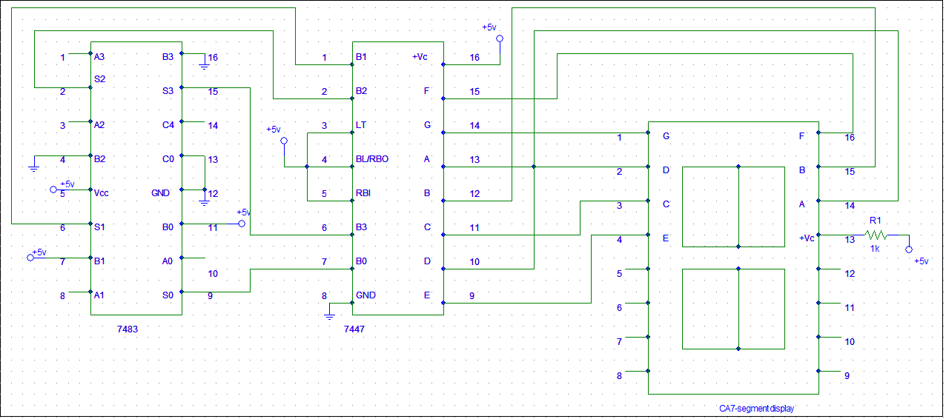
Figure: Diagram of the lab experiment setup.

Note: For this setup, Inputs must be applied as B₃B₂B₁B₀ to see the valid outputs of the BCD inputs 0000 to 1001
Answer to the Report Questions
Answer to the Question 01
BCD-to-Excess-3 code is a adder circuit. It adds binary number 11 with any input binary number and gives the resultant as output.
The operation of excess three code is simple. It is based on adder circuit. It adds 11 with the input BCD. For example, if we take 0100 as an input, the output will be 0100+0011=0111.
For these, this converter is called BCD-to-Excess-3 code converter.
Answer to the Question 02
Last three digits: 022₁₀
BCD equivalent: 0000 0010 0010
Binary equivalent:1*00000010+1*00010100=00010110
Excess-3 code: 10110+00011=11001
So, Binary equivalent of last three digits of my ID using Excess-3 code is: 11001

Conclusion: This experiment shows us the properties of BCD and also how to operate a seven segment display with BCD. We have to cheak the IC numbers carefully that, is it functioning or not. If there is any problem in7447 IC, signal will not transmit toward the 7 segment display.

