Dept. of EEE, EWU, Summer 2014

Course Name : Digital Logic Design
Course Code : EEE205
Experiment No : 02

Name of the Experiment : Implementation of Boolean Function Using AND, OR, and
NOT Logic Gates.

Date of Performance : 20/05/2014
Date of submission : 28/05/2014

Group no. : 01
Student’s ID : 2013-1-80-022
Student’s name : Md. Solayman Khan

Objective Of The Experiment:
In this particular experiment, we have learned about Boolean functions briefly and also got more familiarity with different logic gate containing IC’s like 7404,7408and 7432.

Name of the IC’s:
- 1 pc 7404- hex inverter
- 2 pcs.7408- quad 2-input AND gate
- 1 pc 7432- quad 2-input OR gate

Circuit diagrams:
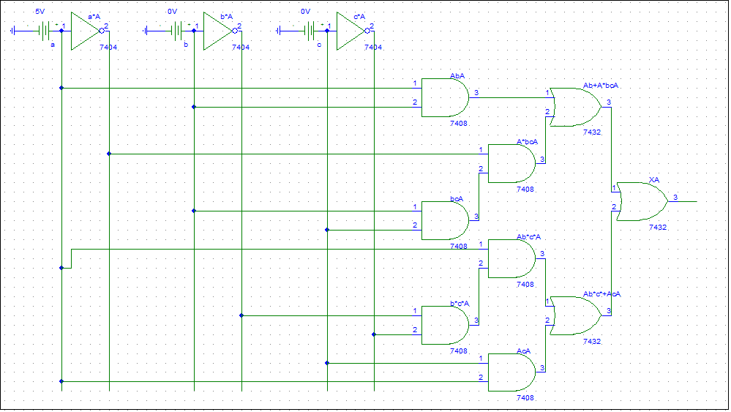
Figure1: Diagram of the circuit for $X=\overline{A}BC+A\overline{B}\overline{C}+AC+AB$
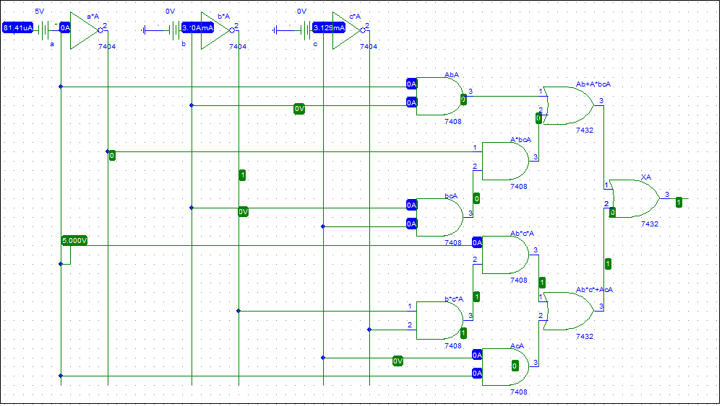
Figure2: Simulation of the circuit of figure1 at a=1,b=0,c=0

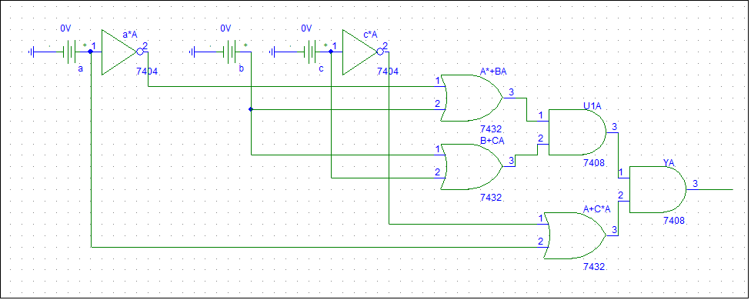
Figure3: Diagram of the circuit for $Y=\left(A+\overline{C}\right)\left(B+C\right)(\overline{A}+B)$
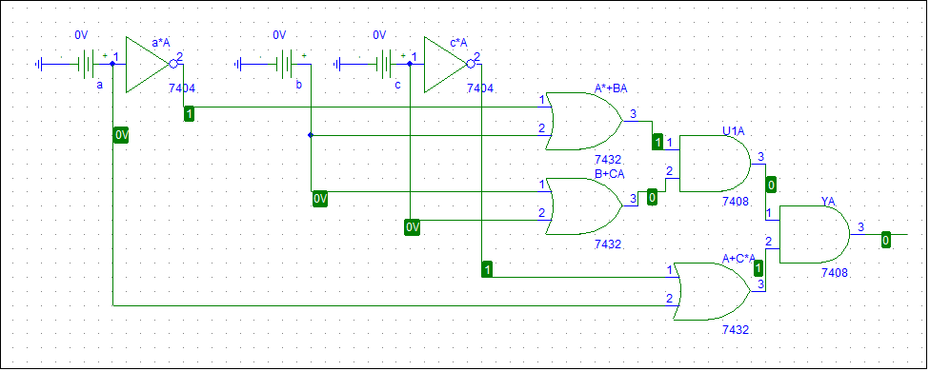
Figure4: Simulation of the circuit of figure3 at a=0,b=0,c=0

Answer to the Report Questions

Answer to the Question 01
The truth table for $X=\overline{A}BC+A\overline{B}\overline{C}+AC+AB$ is given below-
Inputs |  |  | Combinations |  |  |  | Output
A | B | C | $$\overline{A}BC$$ | $$A\overline{B}\overline{C}$$ | $$AC$$ | $$AB$$ | X
0 | 0 | 0 | 0 | 0 | 0 | 0 | 0
0 | 0 | 1 | 0 | 0 | 0 | 0 | 0
0 | 1 | 0 | 0 | 0 | 0 | 0 | 0
0 | 1 | 1 | 1 | 0 | 0 | 0 | 1
1 | 0 | 0 | 0 | 1 | 0 | 0 | 1
1 | 0 | 1 | 0 | 0 | 1 | 0 | 1
1 | 1 | 0 | 0 | 0 | 0 | 1 | 1
1 | 1 | 1 | 0 | 0 | 1 | 1 | 1

Verification: This table is completely same with the table in pre-lab.
Now,
The truth table for $Y=\left(A+\overline{C}\right)\left(B+C\right)(\overline{A}+B)$ is given below-
Inputs |  |  | Combinations |  |  | Output
A | B | C | $$\left(A+\overline{C}\right)$$ | $$\left(B+C\right)$$ | $$(\overline{A}+B)$$ | Y
0 | 0 | 0 | 1 | 0 | 1 | 0
0 | 0 | 1 | 0 | 1 | 1 | 0
0 | 1 | 0 | 1 | 1 | 1 | 1
0 | 1 | 1 | 0 | 1 | 1 | 0
1 | 0 | 0 | 1 | 0 | 0 | 0
1 | 0 | 1 | 1 | 1 | 0 | 0
1 | 1 | 0 | 1 | 1 | 1 | 1
1 | 1 | 1 | 1 | 1 | 1 | 1

Verification: This table is also same with the table in pre-lab.

Answer to the Question 02
Transforming X to standard form:
$X=\overline{A}BC+A\overline{B}\overline{C}+AC+AB$
=$\overline{A}BC+A\overline{B}\overline{C}+AC(B+\overline{B})+AB(C+\overline{C})$
=$\overline{A}BC+A\overline{B}\overline{C}+ABC+A\overline{B}C+ABC+AB\overline{C}$
=$\overline{A}BC+A\overline{B}\overline{C}+ABC+A\overline{B}C+AB\overline{C}$
Truth table for standard form of X:
Inputs |  |  | Combinations |  |  |  |  | Output
A | B | C | $$\overline{A}BC$$ | $$A\overline{B}\overline{C}$$ | $$ABC$$ | $$A\overline{B}C$$ | $$AB\overline{C}$$ | X
0 | 0 | 0 | 0 | 0 | 0 | 0 | 0 | 0
0 | 0 | 1 | 0 | 0 | 0 | 0 | 0 | 0
0 | 1 | 0 | 0 | 0 | 0 | 0 | 0 | 0
0 | 1 | 1 | 1 | 0 | 0 | 0 | 0 | 1
1 | 0 | 0 | 0 | 1 | 0 | 0 | 0 | 1
1 | 0 | 1 | 0 | 0 | 0 | 1 | 0 | 1
1 | 1 | 0 | 0 | 0 | 0 | 0 | 1 | 1
1 | 1 | 1 | 0 | 0 | 1 | 0 | 0 | 1

Verification: This truth table is also same with the truth table of X in pre-lab.

Transforming Y to standard form:
$$Y=\left(A+\overline{C}\right)\left(B+C\right)(\overline{A}+B)$$
$\overline{Y}=\overline{\left(A+\overline{C}\right)}$+$\overline{\left(B+C\right)}$+$\overline{\left(\overline{A}+B\right)}$
$$\overline{Y}=\overline{A}C+\overline{B}\overline{C}+A\overline{B}$$
$$\overline{Y}=\overline{A}(B+\overline{B})C+(A+\overline{A})\overline{B}\overline{C}+A\overline{B}(C+\overline{C})$$
$$\overline{Y}=\overline{A}BC+\overline{A}\overline{B}C+A\overline{B}\overline{C}+\overline{A}\overline{B}\overline{C}+A\overline{B}C+A\overline{B}\overline{C}$$
$$\overline{Y}=\overline{A}BC+\overline{A}\overline{B}C+A\overline{B}\overline{C}+\overline{A}\overline{B}\overline{C}+A\overline{B}C$$
$$Y=\overline{\overline{A}BC+\overline{A}\overline{B}C+A\overline{B}\overline{C}+\overline{A}\overline{B}\overline{C}+A\overline{B}C}$$
Y=$(A+\overline{B}+\overline{C})(A+B+\overline{C})(\overline{A}+B+C)(A+B+C)(\overline{A}+B+\overline{C})$
Truth table for standard form of Y:
Inputs |  |  | Combinations |  |  |  |  | Output
A | B | C | $$A+\overline{B}+\overline{C}$$ | $$A+B+\overline{C}$$ | $$\overline{A}+B+C$$ | $$A+B+C$$ | $$\overline{A}+B+\overline{C}$$ | Y
0 | 0 | 0 | 1 | 1 | 1 | 0 | 1 | 0
0 | 0 | 1 | 1 | 0 | 1 | 1 | 1 | 0
0 | 1 | 0 | 1 | 1 | 1 | 1 | 1 | 1
0 | 1 | 1 | 0 | 1 | 1 | 1 | 1 | 0
1 | 0 | 0 | 1 | 1 | 0 | 1 | 1 | 0
1 | 0 | 1 | 1 | 1 | 1 | 1 | 0 | 0
1 | 1 | 0 | 1 | 1 | 1 | 1 | 1 | 1
1 | 1 | 1 | 1 | 1 | 1 | 1 | 1 | 1

Verification: This truth table is also same with the truth table of Y in pre-lab.

Conclusion:
In this experiment, we have verified the Boolean functions both of SOP and POS form.From this experiment, it is clear to us that, the output function is always same for both normal form and standard form, if there is no mistake. Our skill of transforming from SOP to POS and from POS to SOP is also sharpened through this experiment.

