EAST WEST UNIVERSITY
Department of Electrical and Electronic Engineering
Course: EEE307 (Telecommunication Engineering)
Experiment No 1: Double Sideband-Suppressed Carrier (DSB-SC)

Submitted by
Md. Solayman Khan
2013-1-80-022
Group no: 04
Group Members name: Group Members SID:
1.
2.
3.
4.
5.
6.
7.

Section no.: 01
Date of submission: 30/01/2015
Date of performance: 13/01/2015
Course instructor: MBS
Objective: The objective of this experiment is to make us familiar with the DSB-SC modulation. This experiment was basically the starting of hand-on work of telecommunication signal.

Circuit Diagram:
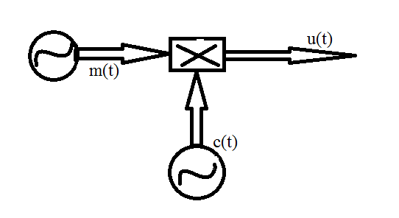
Figure-01: DSB-SC modulated signal generation
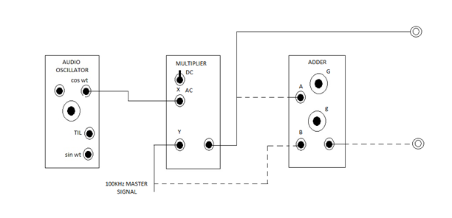
Figure-02: Module connection for DSB-SC generation
Experimental Results:
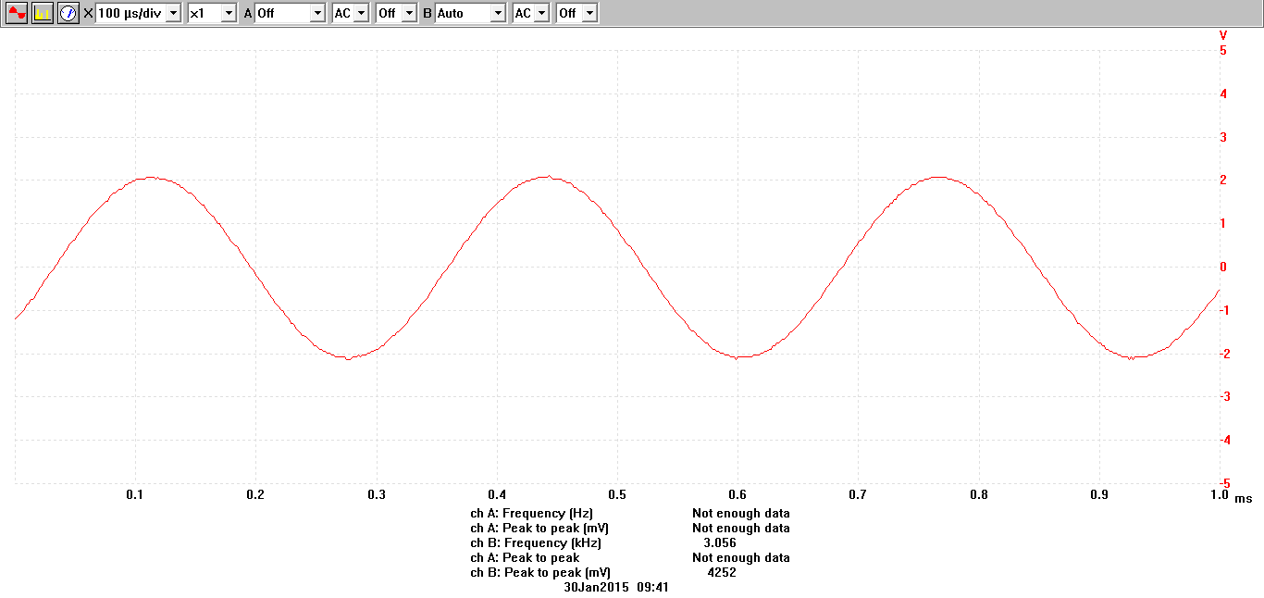
Figure-03: waveform of m(t) at 3.056 KHz

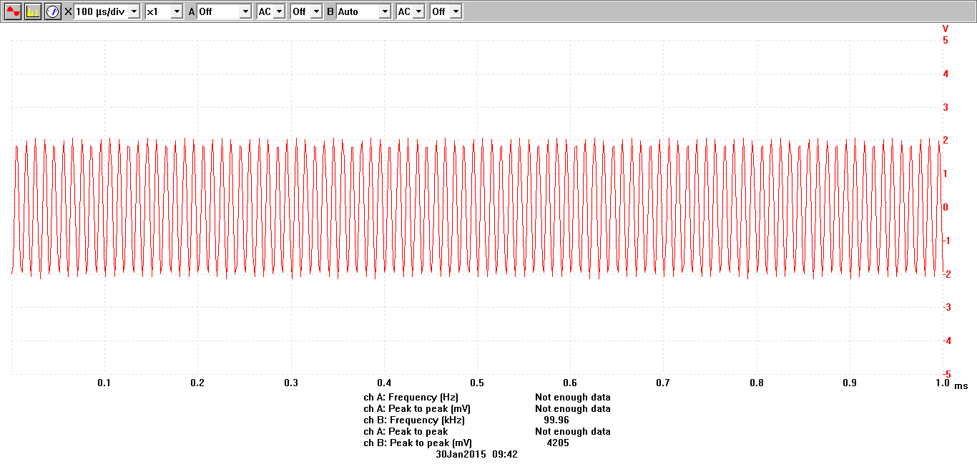
Figure-04: waveform of c(t) at 99.96 KHz

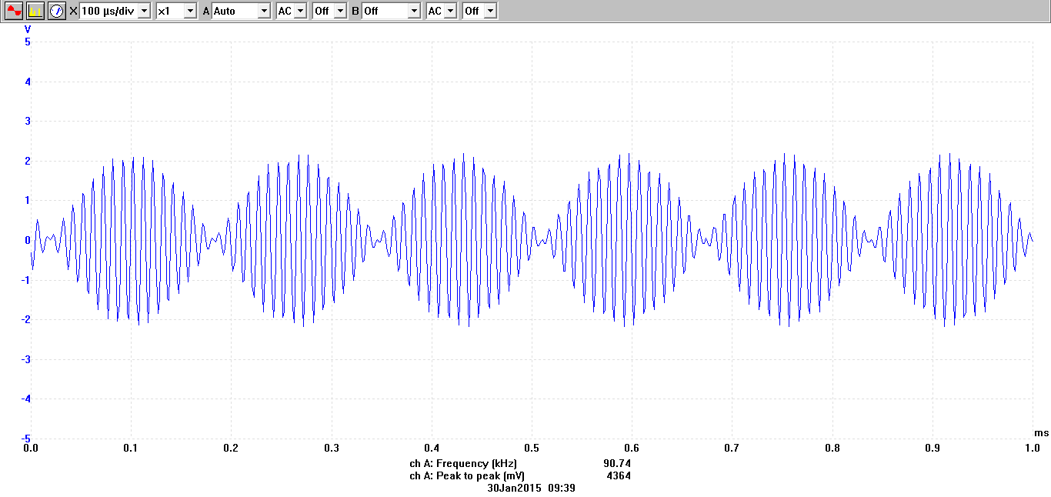
Figure-05: Waveform of u(t) at 90.74 KHz

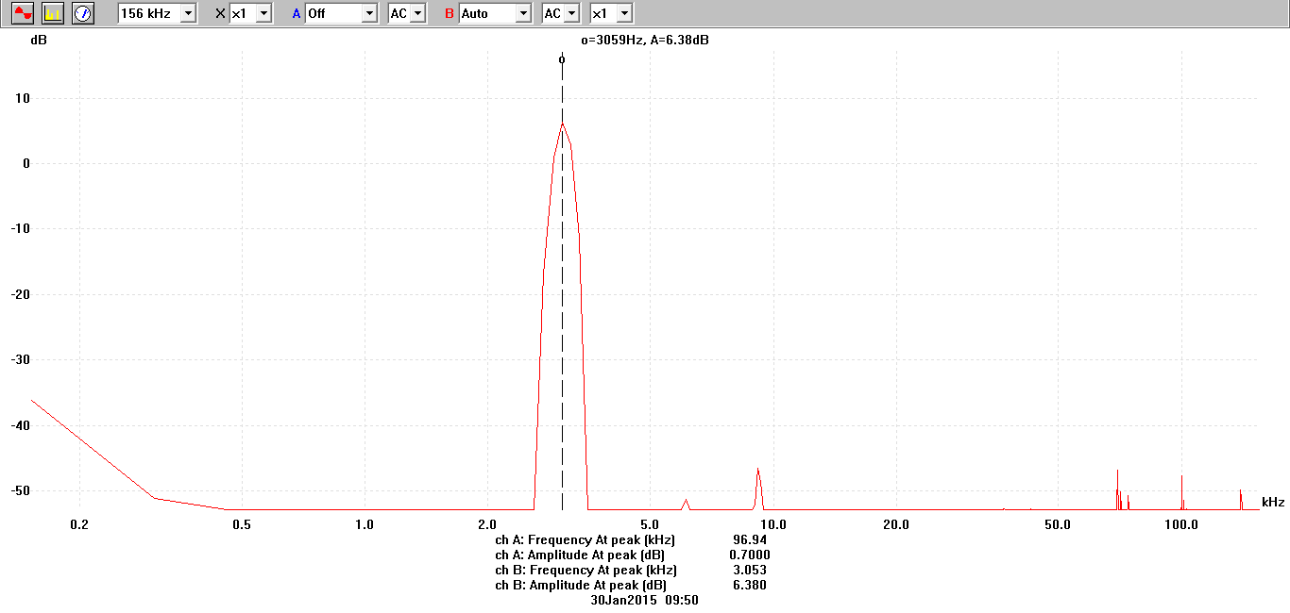
Figure-06: Waveform of M(f) at 3.053KHz
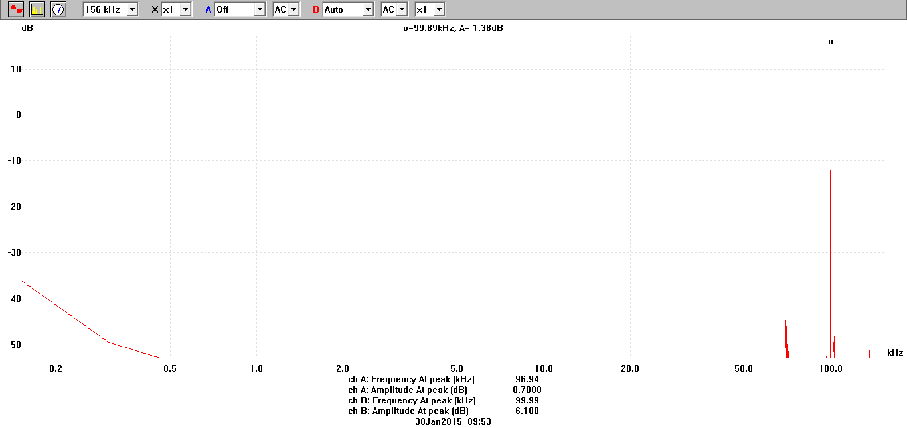
Figure-07: Waveform of C(f) at 99.99KHz

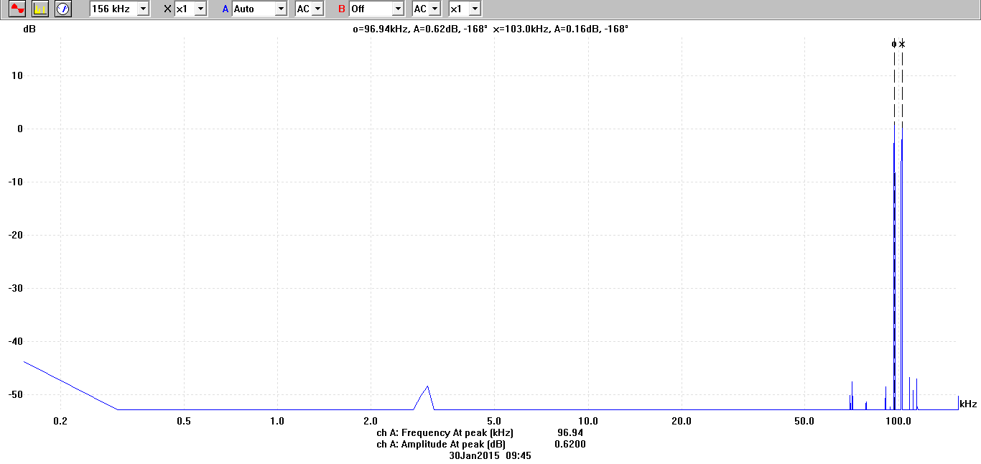
Figure-08: Waveform of U(f) at 96.94KHz

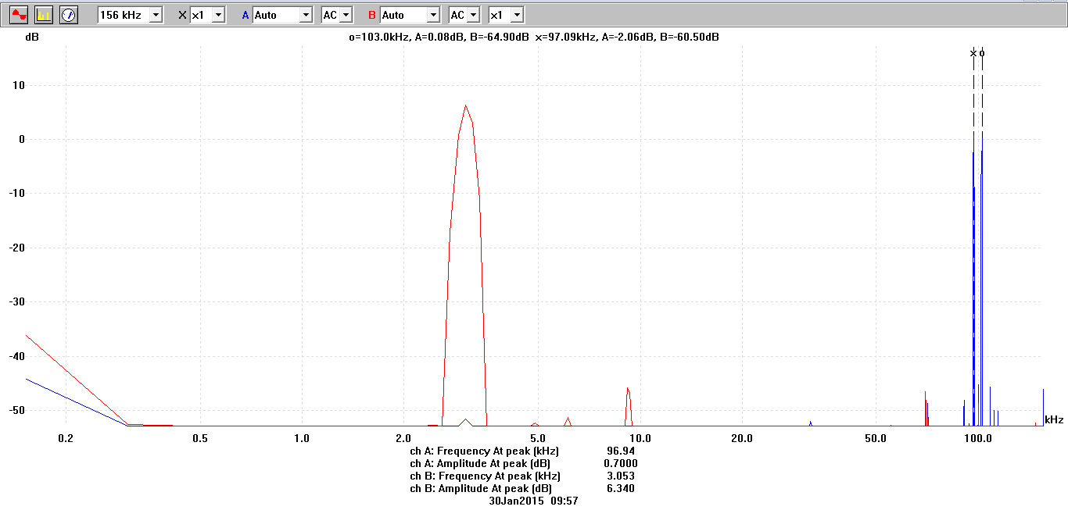
Figure-09: Waveform of U(f)=96.94 KHz and M(f)=3.053 KHz together

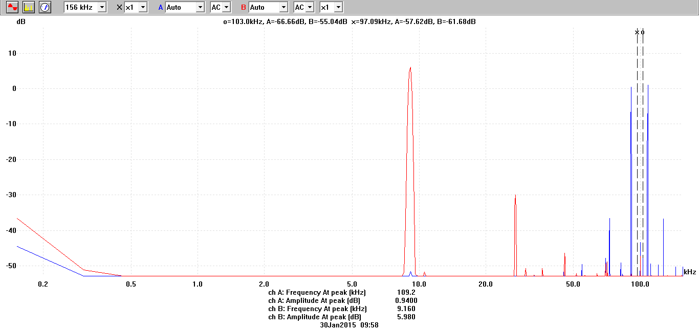
Figure-10: Waveform of U(f)=109.2KHz and M(f)=9.16KHz after varying message frequency
Answers to the post-lab report questions
Answer to the question no.01:

DSB-SC means double sideband suppressed carrier. In this lab we have seen that, the modulated signal has double sidebands. From here the name DSB-SC is justified.
Answer to the question no.02:

DSB-SC is advantages to apply in following cases:
- In term of power consumption.
- Power distribution system in sidebands.
- Double bandwidth than the message signal.

Answer to the question no.03:

The adder adds the 100 KHz master signal with the output of multiplier. As a result, the ultimate output always remains larger than the carrier signal.
Answer to the question no.04:

The range of the audio signal used in lab is probably 1 KHz-10 KHz.
Answer to the question no.05:
Some limitations of this experiment are given below.
In this experiment, the modulation only consists of the two symmetrical sidebands. Another limitation is that, the carrier signal component becomes suppressed. So, it does not appear in the output signal when the spectrum of output is viewed.

Conclusion: In this experiment, we have learned DSB-SC modulation. Now it is easy for us to modulate a signal using adder and multiplier. And now we can analyze signals using Picoscope.

References:
- J.G.Proakis and M.salehi, Communication Systems Engineering, 2nd Edition,Pearson Education,Inc.,Delhi, India,2004.

