Dept. of EEE, EWU, Fall 2014

Course Name : Electrical Machines Fundamentals

Course Code : EEE301

Experiment No : 02

Name of Experiment : Determination of the Equivalent
Circuit Parameter of a Transformer

Date of Performance : 16/10/2014

Date of submission : 23/10/2014

Group no. : 02

Student’s ID : 2013-1-80-022

Student’s name : Md. Solayman Khan

Objective:

The objective of this experiment is to study the equivalent circuit of transformer and to determine the transformers

Theory:
The transformer parameters can be obtained by two economic and convenient test without loading it. The tests are open circuit test and short circuit test. Transformer efficiency and regulation can be obtained using these parameters.

The purpose of open circuit test is to determine the no load loss, no load primary current. And using this value, we can find out magnetizing reactance, core loss resistance. This test is performed in low tension side.

P_{OC}=V_{OC}.I_{fe}
Find I_{fe.}

R_{FE}= V_{OC}/I_{fe}
Find R_{fe}

I₀=(I²_{fe}+I²_{M})^{1/2}
Find I_{M}

|X_{m}|=(V_{oc}/I_{m})
Find X_{M}

The purpose of short circuit test is to determine the copper loss, total leakage reactance and total resistance of the transformer referred to the primary side.

Z_{eq}=(V_{SC}/I_{SC})
Find Z_{eq.}

P_{SC}=I²_{SC}R_{eq}
Find R_{eq.}

Z_{EQ}=(R²_{eq}+X²_{eq})
Find X_{eq}

Circuit diagram:

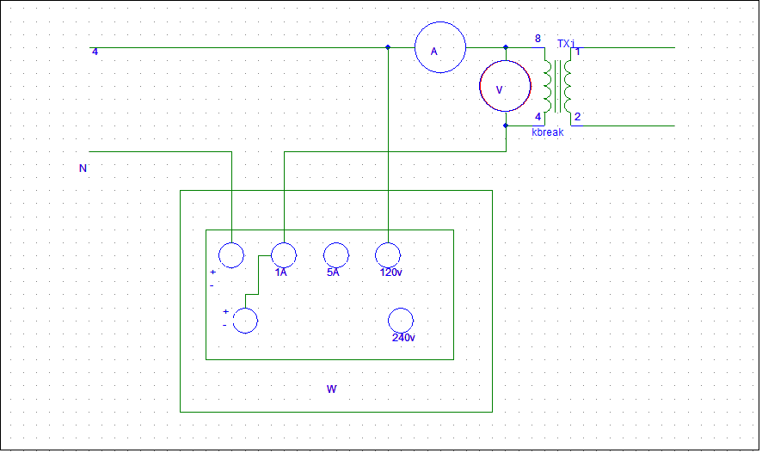
Figure1: Circuit diagram for performing open circuit test

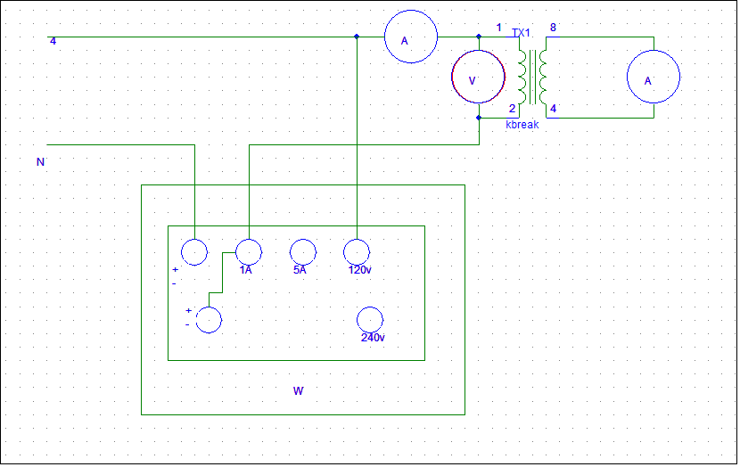Figure2: Circuit diagram for performing short circuit test

Data sheet:

1.
V_{rated,HT}= 240V
I_{rated,HT}=0.25A
V_{rated,LT}= 56V
I_{rated,LT}=0.15A.

2d.
V_{OC}=56V
I_{OC}=0.073A
P_{OC}=4W

3.d.
V_{T}=11V
I_{SC}=0.025A
P_{SC}=2W

Answer to the question no.1

Equivalent circuit parameters for O/C test:

I_{fe} = Poc/Voc
= 4/56
= 0.071 A

R_{fe,ls}= Voc/I_{fe}
= 56/0.071
= 788.73 Ω

I_{m}= √(I²oc-I²_{fe} )
= √ (0.073²-0.071²)
= 0.017 A

X_{m} =V_{OC}/I_{M}
= 56/0.017
= 3.294 KΩ

Equivalent circuit parameters for short circuit test:

Z_{eq,HS} = V_{T}/I_{SC}
= 11/0.025
= 440 Ω

R_{eq,HS}= P_{SC}/I²_{SC}
=2/0.025²
= 3200Ω

X_{eq,HS}=√(Z_{eq,HS}²-R_{eqHS}²)
=√(440²-3200²)
= 3169.60 Ω

Here,
a = 240/56=4.2857

So,
Z_{eq,LS} = Z_{eq,HS} /a²
=440/18.36
=23.95 Ω

Answer to the question no.2
When the circuit is in open circuit condition, the only current used is to magnetize the core and supply the hysteresis loss. These two represents core loss. And when the circuit is shorted, the current passes through the secondary winding. As a result, for the resistive nature of the material of the winding (usually copper), a power dissipates. This loss is called copper loss.
These are the reason why wattmeter reading represents core loss and copper loss in open circuit and short circuit test respectively.

Answer to the question no.3

Figure.3: Vector diagram of a real transformer for resistive, capacitive, inductive load

Answer to the question no.4
In the open circuit test, high tension side is kept open for the measurement safety. And in the short circuit test, the low tension side is shorted for equipment safety.
Theoretically, it is obviously possible to do the test in reverse sides.

Answer to the question no.5
In the short circuit test, the terminals of the transformer are changed. LT side is used as secondary and HT side is used as primary. This is done for the equipment safety. While doing this test, the LT side current increase adequately and reach the rated value very quickly. That is why this modification done.

Discussion & Conclusion
In this experiment, we have learned a lot of things. Now we have idea of how to determine the equivalent circuit parameters of a transformer. Now we know what we have to measure and where we have to measure. We also learned that, how to manipulate the measured values for determining more values.

