**Dept. of EEE, EWU, Fall 2014**

Course Name : Electrical Machines Fundamentals

Course Code : EEE301

Experiment No : 03

Name of Experiment : Study of Performance of a Single

Phase Transformer.

Date of Performance : 16/10/2014

Date of submission : 23/10/2014

Group no. : 02

Student’s ID : 2013-1-80-022

Student’s name : Md. Solayman Khan

Objective:

The objective of this experiment is to study the voltage regulation and efficiency of the transformer with varying loads and to study transformer regulation and efficiency with inductive and capacitive load.

Theory:

The load on a sub-station transformer may vary from very low to very high value in different time of the day. The secondary voltage of transformer vary with the load and its power factor.This variation is expressed in term of voltage regulation. The expression of voltage regulation is:

Voltage Regulation=(VNL-VRated)/Vrated * 100%

Circuit diagram:

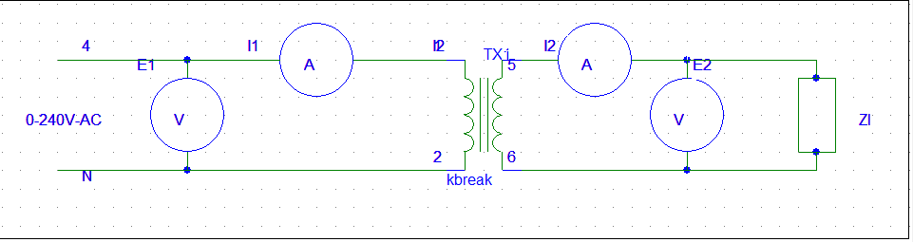

Figure1: Circuit diagram for the measurement

Data sheet:

E1=226V

Table 1: measurement of I1, I2 and E2 for Resistive load.

|  |  |  |  |
| --- | --- | --- | --- |
| ZLoad (Ω) | I1 (A) | I2 (A) | E2 (V) |
| No load | 0 | 0 | 216 |
| 4800 | 0.08 | 0.068 | 218 |
| 2400 | 0.14 | 0.126 | 213 |
| 1600 | 0.125 | 0.182 | 209 |
| 1200 | 0.245 | 0.235 | 203 |

Table 2: measurement of I1, I2 and E2 for inductive load.

|  |  |  |  |
| --- | --- | --- | --- |
| ZLoad (Ω) | I1 (A) | I2 (A) | E2 (V) |
| No load | 0 | 0 | 222 |
| 4800 | 0.08 | 0.065 | 220 |
| 2400 | 0.149 | 0.132 | 218 |
| 1600 | 0.207 | 0.192 | 215 |
| 1200 | 0.275 | 0.275 | 213 |

Table 3: measurement of I1, I2 and E2 for Capacitive load.

|  |  |  |  |
| --- | --- | --- | --- |
| ZLoad (Ω) | I1 (A) | I2 (A) | E2 (V) |
| No load | 0 | 0 | 220 |
| 4800 | 0.055 | 0.065 | 221 |
| 2400 | 0.019 | 0.129 | 222 |
| 1600 | 0.182 | 0.190 | 223 |
| 1200 | 0.238 | 0.248 | 224 |

Answer to the question no.1

Voltage regulation:

Table 4: Voltage regulation for Resistive load

|  |  |  |  |
| --- | --- | --- | --- |
| Load(Ω) | No load ( Enl) | Full Load ( E2) | reg=((Enl-E2)/E2)×100% |
| 4800 | 226 | 218 | 3.67 |
| 2400 | 226 | 213 | 6.10 |
| 1600 | 226 | 209 | 8.13 |
| 1200 | 226 | 203 | 11.33 |

Table 5: Voltage regulation for Inductive load

|  |  |  |  |
| --- | --- | --- | --- |
| Load(Ω) | No load ( Enl) | Full Load ( E2) | reg=((Enl-E2)/E2) ×100% |
| 4800 | 226 | 220 | 2.73 |
| 2400 | 226 | 218 | 3.67 |
| 1600 | 226 | 215 | 5.12 |
| 1200 | 226 | 213 | 6.10 |

Table 6: Voltage regulation for Capacitive Load

|  |  |  |  |
| --- | --- | --- | --- |
| Load(Ω) | No load ( Enl) | Full Load ( E2) | reg=((Enl-E2)/E2) ×100% |
| 4800 | 226 | 221 | 2.26 |
| 2400 | 226 | 222 | 1.80 |
| 1600 | 226 | 223 | 1.35 |
| 1200 | 226 | 224 | 0.89 |

Table 7: Apparent primary and secondary power for Resistive Load

|  |  |  |
| --- | --- | --- |
| Load(Ω) | Primary, S =E1×I1 (AV) | Secondary, S =E2×I2 (AV) |
| 4800 | 18.08 | 14.82 |
| 2400 | 31.64 | 26.84 |
| 1600 | 44.07 | 38.04 |
| 1200 | 55.37 | 47.71 |

Table 8: Apparent primary and secondary power for Inductive Load

|  |  |  |
| --- | --- | --- |
| Load(Ω) | Primary, S =E1×I1 (AV) | Secondary, S =E2×I2 (AV) |
| 4800 | 18.08 | 14.30 |
| 2400 | 33.67 | 28.78 |
| 1600 | 46.78 | 41.28 |
| 1200 | 62.15 | 58.58 |

Table 9: Apparent primary and secondary power for Capacitive Load

|  |  |  |
| --- | --- | --- |
| Load(Ω) | Primary, S=(E1×I1)AV | Secondary, S=(E2×I2)AV |
| 4800 | 14.30 | 14.37 |
| 2400 | 4.94 | 28.64 |
| 1600 | 47.32 | 42.37 |
| 1200 | 61.88 | 55.55 |
|  | | |

Answer to the question no.2



Figure2: voltage regulation curve for resistive load



Figure3: voltage regulation curve for inductive load



Figure4: voltage regulation curve for capacitive load

Answer to the question no.3

a.

Capacitance stores the energy when the input voltage is at peek and supply that energy. As a result, the rms voltage increases. That is why the output voltage increses if we use capacitive load.

b.

The effect of transformer impedence on the regulation is that, if the load is resistive or inductive, the regulation decreases with the increase of load resistance.But tfor the capacitive load, the regulation increases with the increase of load resistance.

c.Short circuit current depends on the transformer impedance. The more the transformer impedance, the less the current pass.

Discussion & Conclusion:

In this experiment, we have learned a lot of things. Now we have idea of how to determine the regulation of a single phase transformer. We have also learned the effect of load on output voltage and the inductive and capacitive load’s application. We also observed how the regulation change with the load.