Dept. of EEE, EWU, Fall 2014

Course Name : Electrical Machines Fundamentals

Course Code : EEE301

Experiment No : 05

Name of Experiment : Torque Speed Characteristic of
Wound Rotor Induction Motor

Date of Performance : 13/11/2014 & 20/11/2014

Date of submission : 22/11/2014

Group no. : 02

Student’s ID : 2013-1-80-022

Student’s name : Md. Solayman Khan

Objective
The objective of this experiment is to study the voltage and current relationship of autotransformer and to learn the process of connecting a standard transformer as an autotransformer.

Theory
Autotransformer is a special type of transformer, having only one winding. This one winding acts as both primary as well as secondary. Its mechanism is quite simple. If we want to use it as a step-up transformer, we have to use a part of the winding as primary and the whole winding as secondary. And if we want to use it as a step-down transformer, we have to use the whole winding as primary and a part of the winding as secondary.
Basically, the working principle of a two winding transformer and autotransformer is same. From primary to secondary, power is transformed by the changing magnetic field and the secondary in turn regulates the current in the primary to set up the required condition of equal primary and secondary power. The turn ratio determines the step up voltage, as well as the secondary voltage. Even though some portions are same, each winding is considered as separate.

Circuit diagram:

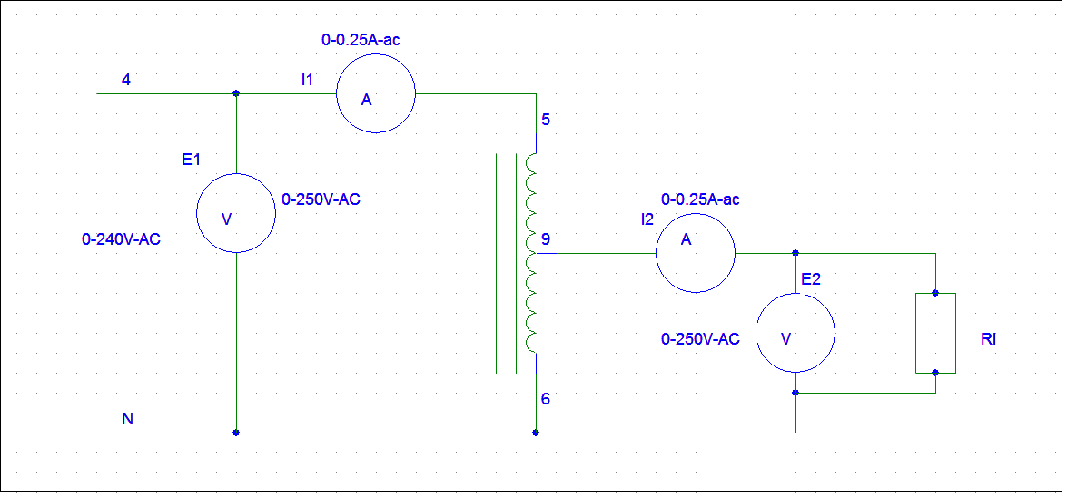
Fig1: Transformer connection in step down mode

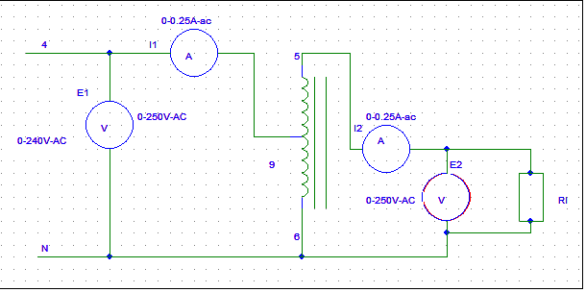
Fig2: Transformer connection in step up mode

Data sheet:

TABLE 1: Step-Down Autotransformer
Load(Ω) | I1(A) | I2(A) | E1(v) | E2(V) | S1(AV) | S2(AV)
0 | 0 | 0 | 220 | 110 | 0 | 0
4800 | 0.02 | 0.025 | 220 | 110 | 4.4 | 2.75
2400 | 0.04 | 0.065 | 220 | 109 | 8.8 | 7.15
1600 | 0.058 | 0.097 | 220 | 108 | 12.75 | 10.573
1200 | 0.074 | 0.128 | 220 | 107 | 16.28 | 13.824

TABLE 2: Step-Up Autotransformer
Load(Ω) | I1(A) | I2(A) | E1(v) | E2(V) | S1(AV) | S2(AV)
0 | 0.025 | 0.010 | 110 | 232 | 2.75 | 2.32
4800 | 0.160 | 0.068 | 110 | 230 | 17.6 | 15.64
2400 | 0.250 | 0.113 | 110 | 228 | 27.5 | 25.76

Answer to the question no.1
In ideal condition, input apparent power is equal to the output apparent power. But here two apparent powers for figure-1 are not equal. They are not equal because of some losses of the transformer. The difference of the apparent powers basically supplies the core loss and copper loss.

Answer to the question no.2
A step down autotransformer configuration is shown in figure 1.

Answer to the question no.3
If we refer to ideal case, input apparent power is equal to the output apparent power. But here two apparent powers for figure-2 are not equal. But they can be considered as approximately equal. They are not exactly equal because of some losses like, core loss and copper loss.

Answer to the question no.4
A step up autotransformer configuration is shown in figure 2.

Answer to the question no.5
- Rated apparent power = 55 KVA
Rated Primary voltage,V_{P} = 650v
Rated Secondary voltage,V_{S} = 220 V
Rated Primary Current, I_{P} = (55000/650) = 84.61 A
Rated Secondary Current, Is = (55000/220) = 250 A

- Trans ratio, a = (650/220) = 2.95
Secondary voltage V_{s} = (500/ a) = 169.49 V
Rated Secondary Current, Is = 250 A
So, maximum KVA load =Vs*Is= (169.49)*(250)= 42372.88VA= 42.37kW

Answer to the question no.6
- In step-up mode, output voltage: V_{O}=a*V_{in}=2.95*500=1475V
In step-down mode, output voltage: V_{O}= V_{in}/a=500/2.95=169.49V
- For step down autotransformer
S_{at} =S_{2w}(1+a)=55000*(1+2.95)=217250AV=217.25KAV
For step up autotransformer
S_{at}=S_{2w}(a-1) )= 55000*(2.95-1)=107250AV=107.25KAV
- For step up autotransformer, I_{out}=217250/1475=147A
For step down autotransformer, I_{out}=107250/169.49=632.78A

Statement: Here, both primary and secondary current exceeds the rated current.

Answer to the question no.7
If, primary is fixed at 240Vac,
- To get 296V output, we have to use terminal 3to4 as Primary winding and terminal 3to8 as secondary.
- To get 654V output, we have to use terminal 7to8 as Primary winding and terminal 3to4 as secondary.
- To get 448V output, we no possible autotransformer winding setup if the input is 240V.
- To get 599V output, we have to use terminal 7to4 as Primary winding and terminal 3to4 as secondary.

Discussion & Conclusion
In this experiment, we have learned a lot of things. Now we have idea of how to use a autotransformer. We have fulfilled all the targets of this experiment. Now we can use the taps of the autotransformer to set our required output voltage. Step up and step down actions using autotransformer and lot more factors are now clear to us.

